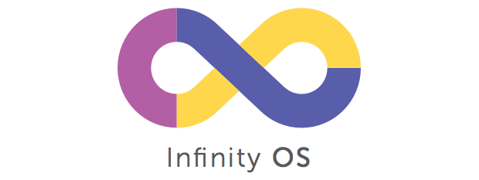
D KARTHIK
XII - A

Infinity os
project documentation
CBSE Board project

Acknowledgement

I would like to express my sincere thanks and heartfelt gratitude to my teachers Ms. Shivshakti Jayakumar as well as my Principal Ms. Sabitha Ramamurthy and Vice Principal Ms. Shyla Purushotham who gave my team and me, the valuable opportunity and supportive infrastructure along with educative support and information to work on this Physics Project on the topic Infinity OS.
The project also encouraged my team-mates Aditya K, Joel Thomas, Siddarth Reddy and me in doing a lot of background research work and gaining experience. We learnt several new aspects of the subject and developed a lot of skills in handling practical difficulties of executing a theory.
Finally, I would also like to thank my team-mates, parents and friends who helped me finalize and improve my product through their suggestions and helped us successfully complete it well within the allotted time frame. Thank you all.



Certificate

This is to certify that Master D Karthik of Grade XII Section A having Board Roll No. 4634825 has satisfactorily completed the Board Project in Practical Computer Science prescribed by the Central Board of Secondary Education (AISSCE) during the year 2018-19

Internal Examiner’s External Examiner’s
Signature Signature

Contents
Acknowledgement 1
Introduction 4
System Requirements 5
Flow Chart 6
Functions List 11
User Defined 11
Main.cpp 11
operations.h 11
user.h 12
server.h 14
client.h 15
comm_func.h 16
ip_finder.h 17
stack.h 18
calendar.h 19
tictactoe.h 19
calculator.h 20
converter.h 20
Built-In Functions 20
Source Code 25
Main.cpp 25
server.h 43
client.h 47
user.h 50
comm_func.h 57
ip_finder.h 62
stack.h 64
operations.h 66
calendar.h 69
tictactoe.h 71
calculator.h 78
converter.h 81
Sample Outputs 87
Constraints and Scope 98
Bibliography 99

Introduction

The modern-day world has evolved to an extent where almost everything we do in our everyday life is computerized, be it booking tickets or managing finances and accounts.
Any computer requires an efficient Operating System (OS) that takes care of basic operations that a user might need and at the same time provide unique features to enrich their experience and comfort.
The key aim of our project is to simulate a Command-Line based User-Interface of an operating system
The most embarking features of our operating system are:
A TCP/IP based two-user chat feature, in an attempt to meet the need and comfort of wireless communication within a Local Area Network, that allows two users connected to the same local network to communicate through text-based instant messaging.
Differentiating ourselves from traditional calculators, we have also included a Single-Line Expression Evaluator that also simulates how compilers process expression evaluations using Infix-Postfix Conversions and Stacks.
Alongside which, we have also integrated some basic features to meet the regular operational needs of a user:
- Scientific Calculator for common mathematical operations,
- Calendar that can generate the calendar of any year,
- Unit Convertor to interconvert among various units,
- Memos to note important points and reminders,
- Tic-Tac-Toe Game, etc.
This operating system aims to provide users an old-school command-line experience on some of the most useful features that one normally uses on a Graphical User Interface (GUI).

System Requirements

- Windows XP/7/8/10 Operating System

- Device must have a Network Interface Card (NIC) allowing it to connect to a Local Area Network

- All necessary firewall permissions to receive and send data across local network devices and allow port binding over the network

- Free ports for TCP/IP Communication

- Firewall permission to run system command for IP Address and Directory Operations

- Administrative permissions for the software to perform directory operations such as creating and destroying directories directly through the execuatable

- Minimum 2.5MB Hard Disk Space (memory occupied will dynamically increase with increasing users and user logs)

- Computer Peripherals Required – Keyboard, Monitor. Mouse

Flow Chart

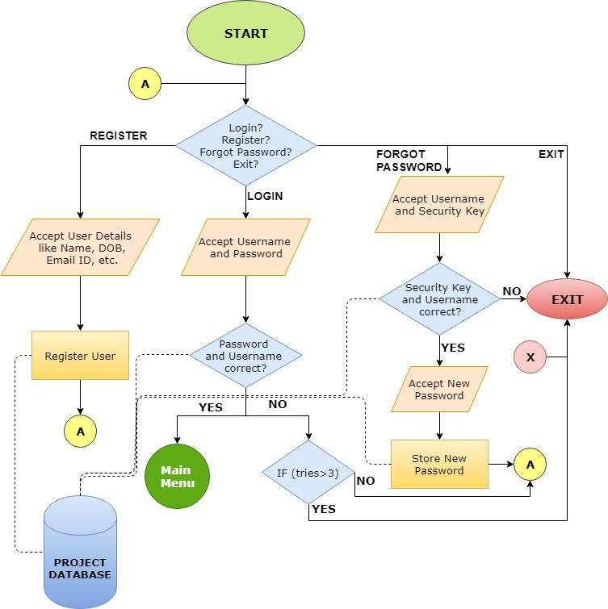

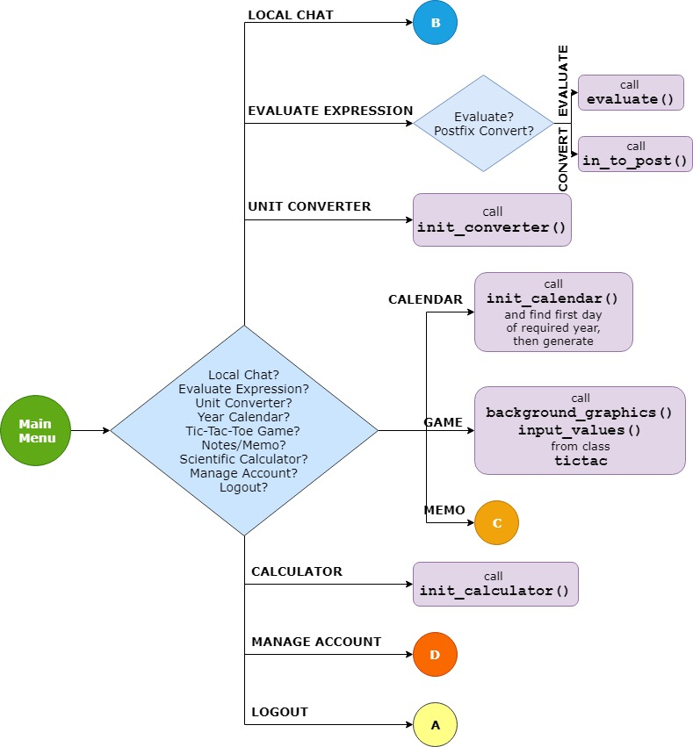

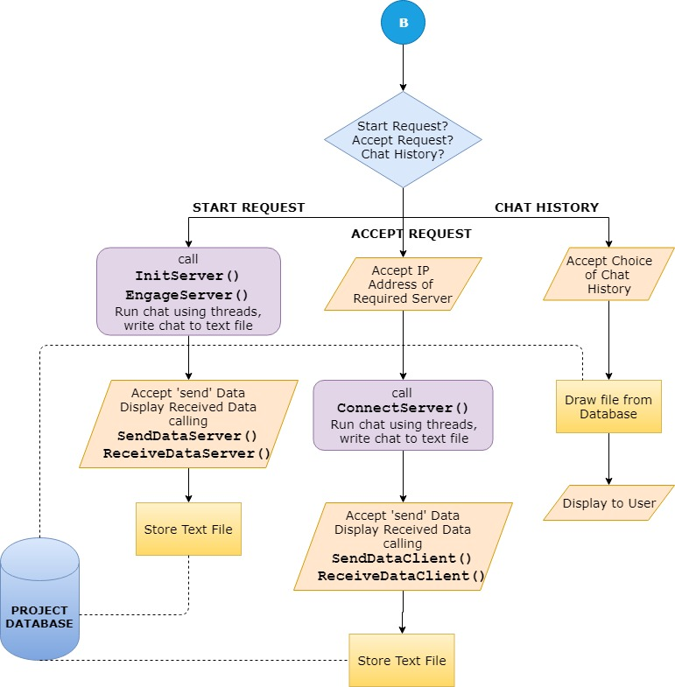

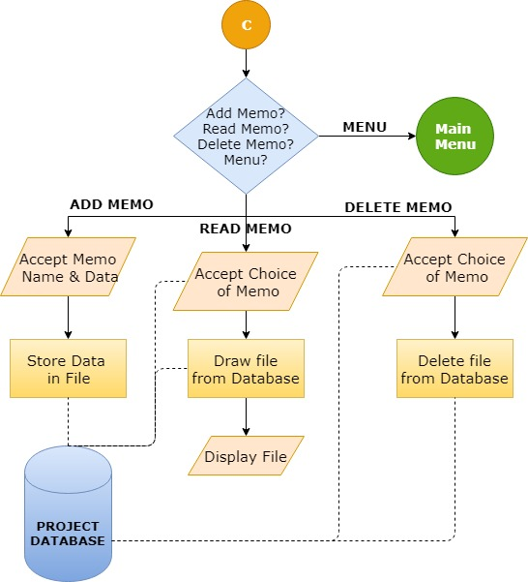

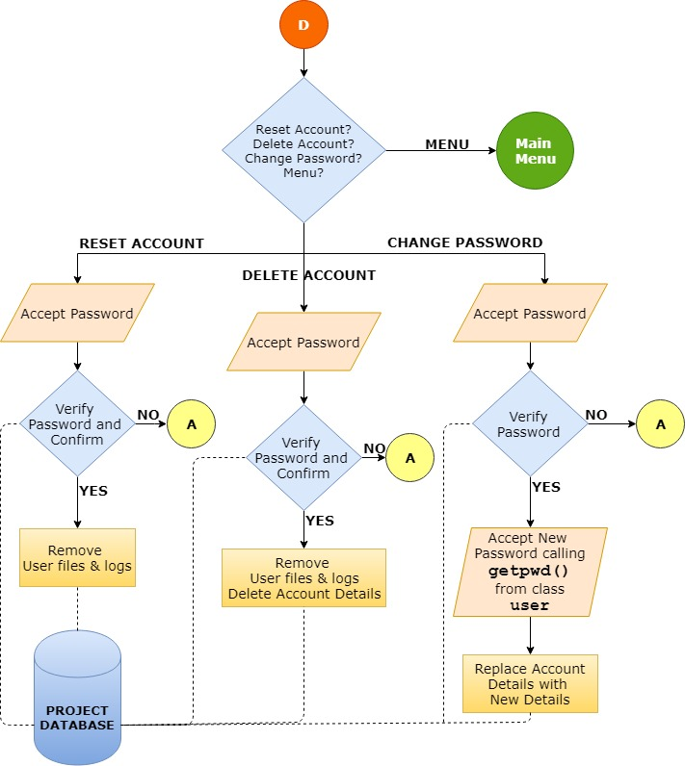

Functions List

User Defined

Main.cpp

FUNCTION PROTOTYPE | RETURN TYPE | DESCRIPTION
main() | int | To handle all operation initiations and maintain the sequence of execution. The starting function of the program sequence
beginSession(user curr) | void | To begin a user session after successful login. Takes the logged in user object as argument

operations.h

FUNCTION PROTOTYPE | RETURN TYPE | DESCRIPTION
preference(char op) | int | To return the precedence ranking of the supplied operator
brackets(char exp[]) | int | To check and return whether the opening and closing parentheses are balanced
search(char ch, char arr[]) | int | To find and return the index of the character from a character array
in_to_post(char exp[],char post[]) | int | To convert the passed infix expression to postfix
final_val(char exp[],float val[], char key[],float &ans) | void | To evaluate the passed postfix expression and store the result in ‘ans’
create_legend(char exp[],float val[], char key[]) | void | To accept and store the values of variables in the user entered expression in an array pair
evaluate(char exp[],char post[],float &ans) | void | To process, manage and distribute work to all functions in the ‘operations’ module

user.h

FUNCTION PROTOTYPE | RETURN TYPE | DESCRIPTION
diff_em_mob(char uid[],long long int &mob) | int | To differentiate between mobile number and email id
charr_to_mob(char uid[],long long int &num) | void | To convert character array of numbers to integer data type
CLASS – ‘person’

get_name() | void | Class function to accept person’s name, correcting errors at the same time
get_dob | void | Class function to accept person’s date of birth, correcting errors at the same time
display() | void | To display all member data of a ‘person’ object
fetch_name(char ret[]) | void | To store the ‘name’ data member of the calling object
CLASS – ‘user’ INHERITED FROM ‘person’

get_pwd() | void | Class function to accept user’s password, correcting errors at the same time
getdata() | void | Class function to accept all data members of the class through its own statements and function calls to other member functions
write_to_file(user curr) | void | To write the current object to the user files
find_user(long long int mobn,user &ret) | bool | Overloaded function to find the ‘user’ object from file using mobile number and store in ‘ret’
find_user(char email[],user &ret) | bool | Overloaded function to find the ‘user’ object from file using email id and store in ‘ret’
create_dir() | void | To create a user directory for a newly created user
login_attempt(long long int mobn, char pass[], user &ret) | bool | To carry out the login process of the user using mobile number and store user in ‘ret’
login_attempt(char email[], char pass[], user &ret) | bool | To carry out the login process of the user using email id and store user in ‘ret’
display() | void | To display all member data of a ‘user’ object
fetch_mob(long long int &ret) | void | To store the mobile number of the calling user in ‘ret’
fetch_email(char ret[]) | void | To store the email id of the calling user in ‘ret’
fetch_pwd(char ret[]) | void | To store the password of the calling user in ‘ret’
fetch_sk() | int | To return the secret key of the calling user

server.h

FUNCTION PROTOTYPE | RETURN TYPE | DESCRIPTION
InitServer(char* ip_host) | SOCKET | To initialize the server socket and bind it to the passed IP address and port for accepting connections
PseudoClient(char* ip_host) | SOCKET | To create a client socket of the same IP address and port to cause server timeout
ServerTimeout(bool &Destroy, char* curr_ip) | void | To initiate server timeout after 15 seconds of listening on port for client
EngageServer(SOCKET ListenSocket,char* curr_ip) | SOCKET | To listen on the server socket and store the connected client’s remote socket in ‘ListenSocket’
ReceiveDataServer(SOCKET ClientSocket, char peer[], ofstream &fout) | void | To receive text data sent by connected client and display on screen and store in file having stream object ‘fout’
SendDataServer(SOCKET ClientSocket, ofstream &fout) | void | To send text data to connected client and store in file having stream object ‘fout’

client.h

FUNCTION PROTOTYPE | RETURN TYPE | DESCRIPTION
ConnectServer(char* ip_host) | SOCKET | To connect to a server looking for connections using the server’s IP address
ReceiveDataClient(SOCKET ConnectSocket, char peer[], ofstream &fout) | void | To receive text data sent by connected server and display on screen and store in file having stream object ‘fout’
SendDataClient(SOCKET ConnectSocket, ofstream &fout) | void | To send text data to connected client and store in file having stream object ‘fout’

comm_func.h

FUNCTION PROTOTYPE | RETURN TYPE | DESCRIPTION
trim(char str[],int max_size) | void | Function to remove leading and trailing whitespaces from a character array
first_day(int year) | int | To return the first day of a given year
num_to_charr(int num,char arr[]) | void | To convert an integer to character array
charr_to_num(char arr[],int &num) | void | To convert a character array having only digits to integer
search_in(char arr[][10],int N,char item[]) | int | To find and return the index of a character array in an array of character arrays
all_digit(char str[]) | bool | To check whether all members of a character array are digits
capitalise(char str[]) | void | To capitalize the first letter of all words in a character array
email_ver(char str[]) | bool | To check whether the given email id is a valid one
del_dir(char path[]) | void | To delete the directory whose path is passed
date_check(int day,int month,int year) | bool | To check whether the given date is possible
date_cmp_curr(int day, int mon, int year) | bool | To check whether current date is in future or past returning ‘true’ if in past
date_time_now(char arr[]) | void | To store the current date and time in ‘arr’ in a specific format
corr_fname(char arr[],char temp[]) | void | To correct the given filename to remove  suspected garbage values
pwd_qual(char pwd[]) | bool | To check whether a password meets specified criteria

ip_finder.h

FUNCTION PROTOTYPE | RETURN TYPE | DESCRIPTION
ipc_tofile() | void | To store IP of present system by pinging, in a file
my_ip(char ret_ip[]) | void | To store IP extracted from the file in ‘ret_ip’
valid_ip(char* ip) | bool | To check whether an IP is valid or not purely in terms of character types

stack.h

FUNCTION PROTOTYPE | RETURN TYPE | DESCRIPTION
CLASS ‘stack’

CreateNewNode(char ch) | node* | Overloaded function to create a new node of character data type
CreateNewNode(float num) | node* | Overloaded function to create a new node of float data type
push(char ch) | void | Overloaded function to push a node of character data type
push(float num) | void | Overloaded function to push a node of floatdata type
pop(char &ch) | int | Overloaded function to pop a node of character data type
pop(float &num) | int | Overloaded function to pop a node of float data type
peek(char &ch) | void | Overloaded function to get without removing a node of character data type
peek(float &num) | void | Overloaded function to get without removing a node of float data type
display() | void | To display all contents of a ‘stack’ object

calendar.h

FUNCTION PROTOTYPE | RETURN TYPE | DESCRIPTION
generate(int m,int startdate,int year) | int | To generate the calendar of a month using its first day
init_calendar() | void | To initiate the calendar generation process

tictactoe.h

FUNCTION PROTOTYPE | RETURN TYPE | DESCRIPTION
CLASS ‘tictac’

input_values() | void | To accept position and symbol/weapon
starting_window() | void | To accept the player names
check() | void | To check whether the game has reached an end
player1_won() | void | To print the message for a Player 1 winning
player2_won() | void | To print the message for a Player 2 winning
draw_match() | void | To print the message for a draw match
background_graphics() | void | To load the background graphics of a tic-tac-toe board

calculator.h

FUNCTION PROTOTYPE | RETURN TYPE | DESCRIPTION
init_calculator() | void | To initiate the calculator process

converter.h

FUNCTION PROTOTYPE | RETURN TYPE | DESCRIPTION
init_converter() | void | To initiate the converter process

Built-In Functions

FUNCTION PROTOTYPE | RETURN TYPE | DESCRIPTION
gets (char*__s) | char* | To store the keyboard input string as character array in ‘s’
get(char &c) | istream& | To accept a single character from the calling stream
getche(void) | char | To return the character from istream and echoing to output screen
getline(istream& is, string& str, char delim) | istream& | To store input from istream (keyboard) into ‘str’ until delimiter is reached or end of line
read(char* s, streamsize n) | istream& | To extract n characters from calling stream and store them in ‘s’
write(const char* s, streamsize n) | ostream& | To insert first n characters from s into calling stream
open(const char* filename, openmode mode) | void | To associate the specified file with the calling stream in the specified mode (opening file)
close() | void | To unlink the files from the calling stream (closing file)
system(const char* command) | void | To execute the command passed on the computer’s default command processor
isdigit(int c) | int | To check whether the passed character is a digit
isalpha(int c) | int | To check whether the passed character is an alphabet
isalnum(int c) | int | To check whether the passed character is either a digit or an alphabet
time(time_t* timer) | time_t | To return the current time as a value of time_t
localtime(const time_t* timer) | struct tm* | To fill a tm structure using the value of time_t passed
asctime() | char* | To convert the tm structure to a character array
mkdir(char* filename) | int | To create a directory with specified path
chdir(const char *path) | int | To change the current working directory to the path specified
getcwd(char *buf, size_t size) | char* | To store in buf and return the path of current working directory
rmdir(const char *path) | int | To remove the directory specified by the passed path only if empty
opendir(const char *dirname) | DIR* | To open a directory stream specified by the path or directory name and positions it at first entry
readdir(DIR *dirp) | struct dirent* | To return a pointer to dirent structure at current entry and shifts the stream to next entry
closedir(DIR *dirp) | int | To close the directory stream of the path passed
WSAStartUp(WORD wVersion, LPWSADATA lpWSAData) | int | To initiate the use of Winsock DLL
zeroMemory(int* Destn, int len) | void | To fill zeroes i.e. reset the data in a given memory address upto len blocks
getaddrinfo(char* hostname, char* port, addrinfoa type, addrinfoa* res) | int | To convert hostname to address and store structures found into ‘res’ as linked list
WSACleanup() | int | To stop the use of Winsock DLL
WSAGetLastError() | int | To return last error code thrown by socket
socket(int domain, int type, int protocol) | int | To create a new socket with details as passed
freeaddrinfo(addrinfoa addrin) | void | To free the address information that getaddrinfo() allocated
bind(int socket, const struct sockaddr *address,  socklen_t address_len) | int | To assign a local socket address and port to the socket passed
connect(int socket, const struct sockaddr *address,  socklen_t address_len) | int | To attempt to make a connection on the socket passed
listen(int socket, int backlog) | int | To enable the passed socket to accept connections
accept(int socket, struct sockaddr *address, socklen_t* address_len) | int | To accept the first connection from the queue and assign its details to ‘address’
getpeername(int socket, struct sockaddr *address, socklen_t* address_len) | int | To store address details of passed socket in ‘address’
recv(int socket, void *buffer, size_t length, int flags) | int | To receive a data transmitted by its peer
send(int socket, const void *buffer, size_t length, int flags) | int | To initiate the transmission of message to connected peer
strlen(const char *s) | int | To return the size of passed character array
strcat(char *s1,char *s2) | char* | To append copy of s2 to s1 & return s1
strcmp(char *s1,char *s2) | int | To compare two-character arrays
strcpy(char *s1,char *s2) | char* | To copy s2 to s1 and return s1
ignore() | istream& | To extracts and wastes the next character in istream
tolower(int ch) | int | To convert the character to lowercase
toupper(int ch) | int | To convert the character to uppercase
memset(void* str, int ch, size_t n) | void* | To copy value of ‘ch’ into n bytes of ‘str’

Source Code

Main.cpp
- #include<iostream>
- #include<iomanip>
- #include<thread>
- #include<conio.h>
- #include<math.h>
- #include<server.h>
- #include<client.h>
- #include<windows.h>
- #include<ip_finder.h>
- #include<stdlib.h>
- #include<user.h>
- #include<comm_func.h>
- #include<operations.h>
- #include<calendar.h>
- #include<tictactoe.h>
- #include<calculator.h>
- #include<converter.h>

- void beginSession(user curr){
- bool logout = false;
- char currdir[LEN];
- char userdir[LEN];
- getcwd(currdir,LEN);
- strcpy(userdir,currdir);
- strcat(userdir,"\\users\\");
- char u_em[250];
- curr.fetch_email(u_em);
- strcat(userdir,u_em);

- while(true&&!logout){
- char curr_ip[15];
- char peer_ip[15];

- char main_ch;
- char u_name[20];
- curr.fetch_name(u_name);
- system("cls");
- cout << endl << "Current User: " << u_name << "!";
- cout << endl << "1-Local Chat\n2-Evaluate Expressions\n3-Unit Converter\n4-Year Calender\n5-Tic-Tac-Toe Game\n6-Notes/Memos\n7-Scientific Calculator\n8-Manage Account\n9-Log Out\nEnter Choice: ";
- cin >> main_ch;

- if(main_ch=='1'){
- char chat_ch;
- cout << endl << "______________________________LOCAL CHAT______________________________" << endl;
- while(true){
- cout << endl << "1-Initiate Request\n2-Accept Request\n3-Chat History\n4-Main Menu\nEnter Choice: ";
- cin >> chat_ch;

- if(chat_ch=='1'){
- char chs;
- my_ip(curr_ip);
- SOCKET Listen;
- cout << endl << "Target must use this IP Address to Accept your request\n" << curr_ip << endl;
- Listen = InitServer(curr_ip);

- if(Listen==INVALID_SOCKET){
- cout << endl << "Server Error Occurred!\nPlease retry shortly..." << endl;
- continue;
- }
- else{
- SOCKET Client;
- Client = EngageServer(Listen,curr_ip);

- if (Client==INVALID_SOCKET){
- cout << endl << "Couldn't Connect to Client.\nEnsure that client entered the correct IP..." << endl;
- }
- else{
- struct sockaddr_in detail;
- socklen_t det_len = sizeof(detail);
- getpeername(Client,(struct sockaddr*)&detail,&det_len);
- strcpy(peer_ip,inet_ntoa(detail.sin_addr));

- cout << endl << "Connected to " << peer_ip << " successfully! " << endl;

- ofstream sfout;
- char now[200];
- strcpy(now,userdir);
- strcat(now,"\\chats\\");
- char store_t[30];
- date_time_now(store_t);
- strcat(now,store_t);
- strcat(now,".txt");
- char now_[200];
- corr_fname(now,now_);
- sfout.open(now_,ios::out);
- sfout << curr_ip << endl << peer_ip;

- thread ReceiveProcessServer(ReceiveDataServer,Client, peer_ip, std::ref(sfout));
- int res_ser;
- while(true){
- cout << endl << "1-Send Text\n2-Terminate Connection\nEnter Choice: ";
- cin >> chs;
- if(chs=='1'){
- res_ser = SendDataServer(Client,std::ref(sfout)); //(std::ref)Creating a reference_wrapper that will be later unpacked in the function
- if(res_ser==1){
- ;
- }
- else if(res_ser==10053 or res_ser==10054){
- cout << endl << "Target closed the connection! Exiting chat... " << endl;
- closesocket(Client);
- WSACleanup();
- break;
- }
- }
- else if(chs=='2'){
- closesocket(Client);
- WSACleanup();
- break;
- }
- else{
- cout << endl << "Invalid Choice!" << endl;
- continue;
- }
- }
- ReceiveProcessServer.join();
- sfout.close();

- ifstream check;
- trim(now_,strlen(now_));
- check.open(now_,ios::in);
- char data[100];
- int ctr = 0;
- while(check){
- check.getline(data,100);
- ctr++;
- }
- check.close();
- if (ctr<=3){
- remove(now_);
- }
- }
- }
- }

- else if(chat_ch=='2'){
- char acip[15];
- bool chat_entry = false;
- SOCKET Conn;

- cin.ignore();
- while(true){
- cout << endl << "Enter IP Address to connect to (X to go back): ";
- gets(acip);

- if(strlen(acip)==1){
- if(acip[0]=='X' or acip[0]=='x'){
- break;
- }
- }

- cout << endl << "Attempting Connection..." << endl;

- Conn = ConnectServer(acip);
- if(Conn==INVALID_SOCKET){
- cout << endl << "Connection Failed!\nPlease Re-Enter the correct IP or press X to exit\nMake sure your peer has started the request" << endl;
- continue;
- }
- else{
- chat_entry = true;
- break;
- }
- }

- if(chat_entry){
- cout << endl << "Connected to " << acip << " successfully! " << endl;

- ofstream cfout;
- char now[200];
- strcpy(now,userdir);
- strcat(now,"\\chats\\");
- char store_t[30];
- date_time_now(store_t);
- strcat(now,store_t);
- strcat(now,".txt");
- char now_[200];
- corr_fname(now,now_);
- cfout.open(now_,ios::out);
- my_ip(curr_ip);
- cfout << curr_ip << endl << acip;

- thread ReceiveProcessClient(ReceiveDataClient,Conn,acip,std::ref(cfout));
- int res_cl;
- char chc;
- while(true){
- cout << endl << "1-Send Text\n2-Terminate Connection\nEnter Choice: ";
- cin >> chc;
- if(chc=='1'){
- res_cl = SendDataClient(Conn,std::ref(cfout));
- if(res_cl==1){
- ;
- }
- else if(res_cl==10053 or res_cl==10054){
- cout << endl << "Target closed the Connection! Exiting... " << endl;
- break;
- }
- }
- else if(chc=='2'){
- closesocket(Conn);
- break;
- }
- else{
- cout << endl << "Invalid Choice!" << endl;
- continue;
- }
- }
- ReceiveProcessClient.join();
- cfout.close();

- ifstream check;
- trim(now_,strlen(now_));
- check.open(now_,ios::in);
- char data[100];
- int ctr = 0;
- while(check){
- check.getline(data,100);
- ctr++;
- }
- check.close();
- if (ctr<=3){
- remove(now_);
- }
- }
- }
- else if(chat_ch=='3'){
- char cd[200];
- memset(cd,0,sizeof(cd));
- strcpy(cd,userdir);
- strcat(cd,"\\chats");
- char ind[100][10];
- char cont[100][100];
- int ctr = 0;
- DIR *dir;
- dir = opendir(cd);
- struct dirent *file;
- char ctr_ch[10];
- cout << endl << "YOUR CHAT HISTORY" << endl;
- while (file=readdir(dir)){
- if(file->d_name[0]!='.'){
- num_to_charr(ctr+1,ctr_ch);
- strcpy(ind[ctr],ctr_ch);
- strcpy(cont[ctr],file->d_name);
- cout << endl << ctr+1 << " - " << file->d_name;
- ctr++;
- }
- }
- closedir(dir);

- if(ctr==0){
- cout << endl << "No chat history available!" << endl;
- continue;
- }

- char f_ch[10];
- cout << endl << "\nChoose file to open (1 to " << ctr << ")\nNOTE: Enter 'X' to exit: ";
- cin.ignore();
- gets(f_ch);
- int retval = search_in(ind,ctr,f_ch);
- if(retval==-1){
- f_ch[0] = tolower(f_ch[0]);
- if(strcmp(f_ch,"x")==0){
- cout << endl << "Exiting..." << endl;
- break;
- }
- else{
- cout << endl << "Invalid Choice!" << endl;
- continue;
- }
- }
- else{
- strcat(cd,"\\");
- strcat(cd,cont[retval]);
- ifstream fin;
- fin.open(cd,ios::in);
- char data[1000];
- fin.getline(data,1000);
- cout << endl << "\t\t" << endl << "__________________________________________________________________";
- cout << endl << "Your IP Was: " << data;
- fin.getline(data,1000);
- cout << endl << "Peer IP Was: " << data << endl;
- while(fin){
- fin.getline(data,1000);
- cout << endl << data;
- }
- cout << endl << "\t\tEND OF CHAT" << endl << "__________________________________________________________________" << endl;
- }
- }
- else if(chat_ch=='4'){
- break;
- }
- else{
- cout << endl << "Invalid Choice!" << endl;
- }
- }
- }

- else if(main_ch=='2'){
- cout << endl << "_________________________EXPRESSION EVALUATOR__________________________" << endl;
- char exp_ch;

- while(true){
- cout << endl << "1-Evaluate One-Line Expression\n2-Only Convert to Postfix\n3-Previous Menu\nEnter Choice: ";
- cin >> exp_ch;
- if(exp_ch=='1'){
- char exp[200];
- char post[200];
- float ans;
- cout << endl << "Enter Expression (with brackets) \nNOTE: For multi-digit constants, enter variable and provide value at prompt\n For single-digit constants, values can be entered directly\nEg: For 2+(3*24.87) ---> 2+(3*A), where A=24.87 " << endl;
- cin.ignore();
- gets(exp);
- evaluate(exp,post,ans);
- cout << endl << "Final Answer: " << ans << endl;
- }
- else if(exp_ch=='2'){
- char exp[200];
- char post[200];
- cout << endl << "Enter Expression (with brackets)\nNOTE: Only single-character constants or variables" << endl;
- cin.ignore();
- gets(exp);
- in_to_post(exp,post);
- cout << endl << "Postfix Expression: " << post << endl;
- }
- else if(exp_ch=='3'){
- break;
- }
- else{
- cout << endl << "Invalid Choice!" << endl;
- continue;
- }
- }
- }

- else if(main_ch=='3'){
- cout << endl << "____________________________UNIT CONVERTER____________________________" << endl;
- init_converter();
- }
- else if(main_ch=='4'){
- cout << endl << "_______________________________CALENDAR_______________________________" << endl;
- init_calendar();
- }

- else if(main_ch=='5'){
- cout << endl << "______________________________TIC-TAC-TOE______________________________" << endl;
- tictac obj;
- obj.starting_window();
- cout<<"The Player's Battleground: \n";
- obj. background_graphics();
- obj.input_values();
- cout << endl << "Exiting..." << endl;
- }

- else if(main_ch=='6'){
- cout << endl << "_________________________________MEMOS________________________________" << endl;
- bool add_e;
- char mem_ch;
- char here[200];
- char name[20];
- while(true){
- cout << endl << "1-Add Memo\n2-Read memo\n3-Delete Memo\n4-Previous Menu\nEnter Choice: ";
- cin >> mem_ch;
- cin.ignore();
- if(mem_ch=='1'){
- ifstream fin;
- ofstream fout;
- memset(here,0,sizeof(here));
- strcpy(here,userdir);
- strcat(here,"\\memos\\");
- add_e = true;
- while(add_e){
- memset(name,0,sizeof(name));
- cout << endl << "Enter Memo Name('X' to go back): ";
- gets(name);
- int len = strlen(name);
- if(len==1){
- if(name[0]=='x' or name[0]=='X'){
- add_e = false;
- break;
- }
- }
- trim(name,100);
- if(len>25 or len<3){
- cout << endl << "Name should be between 3 and 25 characters. \nYou entered " << strlen(name) << " characters"<< endl;
- continue;
- }
- else{
- strcat(here,name);
- strcat(here,".txt");
- fin.open(here,ios::in);
- if(fin){
- cout << endl << "Memo with that name already exists!" << endl;
- continue;
- }
- fin.close();
- break;
- }
- }
- if(!add_e){
- continue;
- }
- fout.open(here);
- char data[100];
- char ch;
- while(true){
- cout << endl << "Enter Data" << endl;
- gets(data);
- fout << data << '\n';
- cout << endl << "More data to enter(y/n)?: ";
- cin >> ch;
- cin.ignore();
- if(ch=='n'){
- break;
- }
- }
- fout.close();
- cout << endl << "Memo Stored" << endl;
- }
- else if(mem_ch=='2'){
- char f_ch[10];
- memset(f_ch,0,sizeof(f_ch));
- char cd[200];
- strcpy(cd,userdir);
- strcat(cd,"\\memos");
- char ind[100][10];
- char cont[100][100];
- int ctr = 0;
- DIR *dir;
- dir = opendir(cd);
- struct dirent *file;
- char ctr_ch[10];
- cout << endl << "YOUR MEMOS" << endl;
- while (file=readdir(dir)){
- if(file->d_name[0]!='.'){
- num_to_charr(ctr+1,ctr_ch);
- strcpy(ind[ctr],ctr_ch);
- strcpy(cont[ctr],file->d_name);
- cout << endl << ctr+1 << " - " << file->d_name;
- ctr++;
- }
- }
- closedir(dir);

- if(ctr==0){
- cout << endl << "No memos available!" << endl;
- continue;
- }

- cout << endl << "\nChoose file to open (1 to " << ctr << ")\nNOTE: Enter 'X' to exit: ";
- gets(f_ch);
- int retval = search_in(ind,ctr,f_ch);
- if(retval==-1){
- f_ch[0] = tolower(f_ch[0]);
- if(strcmp(f_ch,"x")==0){
- cout << endl << "Exiting..." << endl;
- break;
- }
- else{
- cout << endl << "Invalid Choice!" << endl;
- continue;
- }
- }
- else{
- strcat(cd,"\\");
- strcat(cd,cont[retval]);
- ifstream fin;
- fin.open(cd,ios::in);
- char ch;
- cout << endl << "CONTENTS OF '" << cont[retval] << "'\n" << endl;
- while(fin){
- fin.get(ch);
- cout << ch;
- }
- }
- }
- else if(mem_ch=='3'){
- char ch;
- char f_ch[10];
- memset(f_ch,0,sizeof(f_ch));
- char cd[200];
- strcpy(cd,userdir);
- strcat(cd,"\\memos");
- char ind[100][10];
- char cont[100][100];
- int ctr = 0;
- DIR *dir;
- dir = opendir(cd);
- struct dirent *file;
- char ctr_ch[10];
- cout << endl << "YOUR MEMOS" << endl;
- while (file=readdir(dir)){
- if(file->d_name[0]!='.'){
- num_to_charr(ctr+1,ctr_ch);
- strcpy(ind[ctr],ctr_ch);
- strcpy(cont[ctr],file->d_name);
- cout << endl << ctr+1 << " - " << file->d_name;
- ctr++;
- }
- }
- closedir(dir);

- if(ctr==0){
- cout << endl << "No memos available!" << endl;
- continue;
- }

- cout << endl << "\nChoose file to delete (1 to " << ctr << ")\nNOTE: Enter 'X' to exit: ";
- gets(f_ch);
- int retval = search_in(ind,ctr,f_ch);
- if(retval==-1){
- f_ch[0] = tolower(f_ch[0]);
- if(strcmp(f_ch,"x")==0){
- cout << endl << "Exiting..." << endl;
- break;
- }
- else{
- cout << endl << "Invalid Choice!" << endl;
- continue;
- }
- }
- else{
- strcat(cd,"\\");
- strcat(cd,cont[retval]);
- cout << endl << "Delete '" << cont[retval] << "' ? (y/n): ";
- cin >> ch;
- if(ch=='y'){
- remove(cd);
- cout << endl << "Deleted!" << endl;
- }
- else{
- cout << endl << "Deletion Aborted!" << endl;
- }
- }
- }
- else if(mem_ch=='4'){
- break;
- }
- else{
- cout << endl << "Invalid Choice";
- continue;
- }
- }
- }

- else if(main_ch=='7'){
- cout << endl << "_________________________SCIENTIFIC CALCULATOR_________________________" << endl;
- init_calculator();
- }

- else if(main_ch=='8'){
- cout << endl << "______________________________YOUR ACCOUNT______________________________" << endl;
- char man_ch;
- logout = false;
- while(true&&!logout){
- cout << endl << "1-Change Password\n2-Delete Account\n3-Reset Account\n4-Forgot Password\n5-Previous Menu\nEnter Choice: ";
- cin >> man_ch;
- if(man_ch=='1'){
- int tries = 3;
- cin.ignore();
- while(tries>0){
- char pass[20];
- cout << endl << "Enter Password: ";
- gets(pass);
- tries--;
- char comp[20];
- curr.fetch_pwd(comp);
- if(strcmp(comp,pass)){
- cout << "Incorrect Password! Tries Left: " << tries << endl << endl;
- }
- else{
- tries = 3;
- curr.get_pwd();
- user temp1, temp2;
- ofstream fout1,fout2;
- ifstream fin1,fin2;
- fin1.open("user_em.dat",ios::in);
- fin2.open("user_mob.dat",ios::in);
- fout1.open("temp1.dat",ios::out);
- fout2.open("temp2.dat",ios::out);
- bool flag1 = false;
- bool flag2 = false;
- while(fin1||fin2){
- if(fin1){
- fin1.read((char*)&temp1,sizeof(temp1));
- }
- if(fin2){
- fin2.read((char*)&temp2,sizeof(temp2));
- }
- if(fin1){
- char comp[250];
- temp1.fetch_email(comp);
- char here[250];
- curr.fetch_email(here);
- if(strcmp(comp,here)==0){ //lexicographical ordering check
- fout1.write((char*)&curr,sizeof(curr));
- }
- else{
- fout1.write((char*)&temp1,sizeof(temp1));
- }
- }
- if(fin2){
- long long int comp;
- temp2.fetch_mob(comp);
- long long int here;
- curr.fetch_mob(here);
- if(comp==here){
- fout2.write((char*)&curr,sizeof(curr));
- }
- else{
- fout2.write((char*)&temp2,sizeof(temp2));
- }
- }
- }
- fin1.close();
- fin2.close();
- fout1.close();
- fout2.close();
- remove("user_em.dat");
- remove("user_mob.dat");
- rename("temp1.dat","user_em.dat");
- rename("temp2.dat","user_mob.dat");
- cout << endl << "Password Changed Successfully!" << endl;
- logout = true;
- break;
- }
- }
- if(tries<=0){
- cout << endl << "Too many incorrect login attempts. Make sure its the correct User ID" << endl;
- cin.ignore();
- logout = true;
- break;
- }
- }
- else if(man_ch=='2'){
- int tries = 3;
- cin.ignore();
- while(tries>0){
- char pass[20];
- cout << endl << "Enter Password: ";
- gets(pass);
- tries--;
- char comp[20];
- curr.fetch_pwd(comp);
- if(strcmp(comp,pass)){
- cout << "Incorrect Password! Tries Left: " << tries << endl << endl;
- }
- else{
- char ch;
- cout << endl << "Are you sure you want to delete the account?(y/n): ";
- ch = tolower(ch);
- cin >> ch;
- if(ch=='n'){
- cout << endl << "Aborting..." << endl;
- tries = 3;
- break;
- }
- else if(ch=='y'){
- user temp1, temp2;
- ofstream fout1,fout2;
- ifstream fin1,fin2;
- fin1.open("user_em.dat",ios::in);
- fin2.open("user_mob.dat",ios::in);
- fout1.open("temp1.dat",ios::out);
- fout2.open("temp2.dat",ios::out);
- while(fin1||fin2){
- if(fin1){
- fin1.read((char*)&temp1,sizeof(temp1));
- }
- if(fin2){
- fin2.read((char*)&temp2,sizeof(temp2));
- }
- if(fin1){
- char comp[250];
- temp1.fetch_email(comp);
- char here[250];
- curr.fetch_email(here);
- if(strcmp(comp,here)==0){ //lexicographical ordering check
- ;
- }
- else{
- fout1.write((char*)&temp1,sizeof(temp1));
- }
- }
- if(fin2){
- long long int comp;
- temp2.fetch_mob(comp);
- long long int here;
- curr.fetch_mob(here);
- if(comp==here){
- ;
- }
- else{
- fout2.write((char*)&temp2,sizeof(temp2));
- }
- }
- }
- fin1.close();
- fin2.close();
- fout1.close();
- fout2.close();
- remove("user_em.dat");
- remove("user_mob.dat");
- rename("temp1.dat","user_em.dat");
- rename("temp2.dat","user_mob.dat");
- fin1.open("user_em.dat",ios::out);
- fin1.close();
- fin1.open("user_em.dat",ios::out);
- fin1.close();
- del_dir(userdir);
- cout << endl << "Account Deletion Initiated! Please Close and Re-Open the program to complete the process" << endl;
- logout = true;
- break;
- }
- }
- }
- if(tries<=0){
- cout << endl << "Too many incorrect login attempts. Make sure its the correct User ID" << endl;
- logout = true;
- break;
- }
- }
- else if(man_ch=='3'){
- int tries = 3;
- cin.ignore();
- while(tries>0){
- char pass[20];
- cout << endl << "Enter Password: ";
- gets(pass);
- tries--;
- char comp[20];
- curr.fetch_pwd(comp);
- if(strcmp(comp,pass)){
- cout << "Incorrect Password! Tries Left: " << tries << endl << endl;
- }
- else{
- char ch;
- cout << endl << "Are you sure you want to reset the account?(y/n): ";
- ch = tolower(ch);
- cin >> ch;
- if(ch=='n'){
- cout << endl << "Aborting..." << endl;
- tries = 3;
- break;
- }
- else if(ch=='y'){
- char rem[200];
- strcpy(rem,userdir);
- strcmp(rem,"\\chats");
- del_dir(userdir);
- cout << endl << "Account Reset Complete!" << endl;
- logout = true;
- break;
- }
- }
- }
- if(tries<=0){
- cout << endl << "Too many incorrect login attempts. Make sure its the correct User ID" << endl;
- logout = true;
- break;
- }
- }
- else if(man_ch=='4'){
- char sk_entry[10];
- cin.ignore();
- cout << endl << "Enter Secret-Key: ";
- gets(sk_entry);
- if(!all_digit(sk_entry)){
- cout << endl << "Incorrect Secret-Key" << endl;
- continue;
- }
- if(strlen(sk_entry)!=6){
- cout << endl << "Incorrect Secret-Key" << endl;
- continue;
- }
- int sk;
- charr_to_num(sk_entry,sk);
- if(sk!=curr.fetch_sk()){
- cout << endl << "Incorrect Secret-Key" << endl;
- continue;
- }
- curr.get_pwd();
- user temp1, temp2;
- ofstream fout1,fout2;
- ifstream fin1,fin2;
- fin1.open("user_em.dat",ios::in);
- fin2.open("user_mob.dat",ios::in);
- fout1.open("temp1.dat",ios::out);
- fout2.open("temp2.dat",ios::out);
- bool flag1 = false;
- bool flag2 = false;
- while(fin1||fin2){
- if(fin1){
- fin1.read((char*)&temp1,sizeof(temp1));
- }
- if(fin2){
- fin2.read((char*)&temp2,sizeof(temp2));
- }
- if(fin1){
- char comp[250];
- temp1.fetch_email(comp);
- char here[250];
- curr.fetch_email(here);
- if(strcmp(comp,here)==0){ //lexicographical ordering check
- fout1.write((char*)&curr,sizeof(curr));
- }
- else{
- fout1.write((char*)&temp1,sizeof(temp1));
- }
- }
- if(fin2){
- long long int comp;
- temp2.fetch_mob(comp);
- long long int here;
- curr.fetch_mob(here);
- if(comp==here){
- fout2.write((char*)&curr,sizeof(curr));
- }
- else{
- fout2.write((char*)&temp2,sizeof(temp2));
- }
- }
- }
- fin1.close();
- fin2.close();
- fout1.close();
- fout2.close();
- remove("user_em.dat");
- remove("user_mob.dat");
- rename("temp1.dat","user_em.dat");
- rename("temp2.dat","user_mob.dat");
- cout << endl << "New Password Set Successfully!" << endl;
- logout = true;
- break;
- }
- else if(man_ch=='5'){
- break;
- }
- else{
- cout << endl << "Invalid Choice!" << endl;
- continue;
- }
- }
- if(logout){
- cout << endl << "Saved Changes\nLogging Out..." << endl;
- Sleep(500);
- system("cls");
- }
- }

- else if(main_ch=='9'){
- cout << endl << "Logging Out..." << endl << endl;
- Sleep(500);
- system("cls");
- break;
- }

- else{
- cout << endl << main_ch;
- cout << endl << "Invalid Choice!" << endl;
- }
- }
- }

- int main(){
- initial_check();
- system("CLS");

- /*user obj;
- ifstream fin;
- fin.open("user_em.dat",ios::in);
- while(fin){
- fin.read((char*)&obj,sizeof(obj));
- obj.display();
- }
- fin.close();
- cout << endl;
- fin.open("user_mob.dat",ios::in);
- while(fin){
- fin.read((char*)&obj,sizeof(obj));
- obj.display();
- }
- fin.close();*/

- char log_ch;
- user temp;
- bool logout;

- while(true){
- //system("CLS");
- logout = false;
- cout << endl << "_________________INFINITY-OS Welcomes You!_________________" << endl;
- cout << endl << "1-Login\n2-Register New Account\n3-Forgot Password\n4-Exit\nEnter Choice: ";
- cin >> log_ch;
- if(log_ch=='1'){
- char uid[250];
- long long int mob = 0;
- while(true&&!logout){
- memset(uid,0,250);
- cout << endl << "LOGIN";
- cout << endl << "Enter Mobile No./Email ID: ";
- cin.ignore();
- gets(uid);
- long long int mob = 0;
- int result = diff_em_mob(uid,mob);
- if(result==0){
- cout << endl << "Invalid or Unregistered User ID" << endl;
- break;
- }

- int tries = 3;
- while(tries>0){
- char pass[20];
- cout << "Enter Password: ";
- gets(pass);
- tries--;
- bool ses;
- user present;
- if(result==1){
- ses = temp.login_attempt(uid,pass,present);
- }
- else if(result==2){
- ses = temp.login_attempt(mob,pass,present);
- }
- if(!ses){
- cout << "Incorrect Password! Tries Left: " << tries << endl << endl;
- }
- else{
- tries = 3;
- cout << endl << "Logging In..." << endl;
- Sleep(500);
- beginSession(present);
- logout = true;
- break;
- }
- }
- if(tries<=0){
- cout << endl << "Too many incorrect login attempts. Make sure its the correct USER ID" << endl;
- logout = true;
- }
- }
- }
- else if(log_ch=='2'){
- user new_;
- new_.getdata();
- bool res = new_.write_to_file(new_);
- if(!res){
- cout << endl << "User Already Registered! Please try logging in" << endl;
- continue;
- }
- else{
- cout << endl << "User Registered Successfully!" << endl;
- }
- }
- else if(log_ch=='3'){
- char uid[250];
- long long int mob = 0;
- cout << endl << "Enter Mobile No./Email ID: ";
- cin.ignore();
- gets(uid);
- long long int mobi = 0;
- int result = diff_em_mob(uid,mobi);
- if(result==0){
- cout << endl << "Invalid or Unregistered User ID" << endl;
- break;
- }
- user ch;
- if(result==1){
- temp.find_user(uid,ch);
- }
- else if(result==2){
- temp.find_user(mobi,ch);
- }
- char sk_entry[10];
- cout << endl << "Enter Secret-Key: ";
- gets(sk_entry);
- if(!all_digit(sk_entry)){
- cout << endl << "Incorrect Secret-Key" << endl;
- continue;
- }
- if(strlen(sk_entry)!=6){
- cout << endl << "Incorrect Secret-Key" << endl;
- continue;
- }
- int sk;
- charr_to_num(sk_entry,sk);
- if(sk!=ch.fetch_sk()){
- cout << endl << "Incorrect Secret-Key" << endl;
- continue;
- }
- ch.get_pwd();
- user temp1, temp2;
- ofstream fout1,fout2;
- ifstream fin1,fin2;
- fin1.open("user_em.dat",ios::in);
- fin2.open("user_mob.dat",ios::in);
- fout1.open("temp1.dat",ios::out);
- fout2.open("temp2.dat",ios::out);
- bool flag1 = false;
- bool flag2 = false;
- while(fin1||fin2){
- if(fin1){
- fin1.read((char*)&temp1,sizeof(temp1));
- }
- if(fin2){
- fin2.read((char*)&temp2,sizeof(temp2));
- }
- if(fin1){
- char comp[250];
- temp1.fetch_email(comp);
- char here[250];
- ch.fetch_email(here);
- if(strcmp(comp,here)==0){ //lexicographical ordering check
- fout1.write((char*)&ch,sizeof(ch));
- }
- else{
- fout1.write((char*)&temp1,sizeof(temp1));
- }
- }
- if(fin2){
- long long int comp;
- temp2.fetch_mob(comp);
- long long int here;
- ch.fetch_mob(here);
- if(comp==here){
- fout2.write((char*)&ch,sizeof(ch));
- }
- else{
- fout2.write((char*)&temp2,sizeof(temp2));
- }
- }
- }
- fin1.close();
- fin2.close();
- fout1.close();
- fout2.close();
- remove("user_em.dat");
- remove("user_mob.dat");
- rename("temp1.dat","user_em.dat");
- rename("temp2.dat","user_mob.dat");
- cout << endl << "New Password Set Successfully!" << endl;
- continue;
- }
- else if(log_ch=='4'){
- break;
- }
- else{
- cout << endl << "Invalid Choice!" << endl;
- continue;
- }
- }

server.h
- #ifndef WIN32_LEAN_AND_MEAN //To exclude Cryptography, DDE, RPC, Shell and other unnecessary APIs from windows.h
- #define WIN32_LEAN_AND_MEAN
- #endif

- #ifndef SERVER_HEAD
- #define SERVER_HEAD

- #define DEFAULT_PORT "5555"

- #include<fstream>
- #include<iostream>
- #include<string.h>
- #include <winsock2.h>
- #include <windows.h>
- #include <ws2tcpip.h>
- #include <iphlpapi.h>
- #include <thread>
- #include<ctime>
- #include <stdio.h>

- using namespace std;

- SOCKET InitServer(char* ip_host){

- WSADATA sample_obj;
- int retval1 = WSAStartup(MAKEWORD(2,2),&sample_obj);
- if (retval1){
- cout << endl << "Unknown Error Occurred! Please Retry Later..." << endl; //Startup Winsock Failed
- }
- else{
- //Startup Winsock Success

- //Socket Initialization
- struct addrinfo *result=NULL, *ptr=NULL, props;
- ZeroMemory(&props,sizeof(props)); //To assign NULL to every member of the structure
- props.ai_family = AF_INET;
- props.ai_socktype = SOCK_STREAM;
- props.ai_protocol = IPPROTO_TCP;
- props.ai_flags = AI_PASSIVE;

- int retval2 = getaddrinfo(ip_host,DEFAULT_PORT,&props,&result); //Instead of NULL(i.e. INADDR_ANY), IP is specified to limit traffic
- if (retval2){
- cout << endl << "Unknown Error Occurred! Please Retry Later..." << endl; //Address Resolution Failed
- WSACleanup();
- }
- else{ //Address Resolution Success

- //Socket Creation
- SOCKET ListenSocket = INVALID_SOCKET;
- ListenSocket = socket(result->ai_family, result->ai_socktype, result->ai_protocol);
- if (ListenSocket == INVALID_SOCKET){
- cout << endl << "Unknown Error Occurred! Please Retry Later..." << endl; // Socket Creation Failed
- freeaddrinfo(result);
- WSACleanup();
- }
- else{ //Socket Created

- //Binding Socket
- int retval3 = bind(ListenSocket, result->ai_addr, (int)result->ai_addrlen);
- if (retval3==SOCKET_ERROR){ // Socket Binding Failed
- cout << endl << "Unknown Error Occurred! Please Retry Later..." << endl;
- freeaddrinfo(result);
- closesocket(ListenSocket);
- WSACleanup();
- }
- else{ //Bound to socket
- freeaddrinfo(result); // Address Information is not required anymore
- return ListenSocket;
- }
- }
- }
- }
- return INVALID_SOCKET;
- }

- SOCKET PseudoClient(char* ip_host){
- //Winsock Initialisation
- WSADATA sample_obj;
- int retval1 = WSAStartup(MAKEWORD(2,2),&sample_obj);
- if (retval1){
- cout << endl << "Unknown Error Occurred! Please Retry Later..." << endl; //Initialisation failed
- }
- else{
- ; //Startup Done

- //Socket Initialization
- struct addrinfo *result=NULL, *ptr=NULL, props;
- ZeroMemory(&props,sizeof(props)); //To assign NULL to every member of the structure
- props.ai_family = AF_INET;
- props.ai_socktype = SOCK_STREAM;
- props.ai_protocol = IPPROTO_TCP;
- int retval2 = getaddrinfo(ip_host,DEFAULT_PORT,&props,&result);
- if (retval2){ //Address resoltion Failed
- cout << endl << "Unknown Error Occurred! Please Retry Later..." << endl;
- WSACleanup();
- }
- else{
- ; //Address Resolved

- //Create Connection Socket
- ptr = result;
- SOCKET ConnectSocket;
- ConnectSocket = socket(ptr->ai_family,ptr->ai_socktype,ptr->ai_protocol);
- if (ConnectSocket==INVALID_SOCKET){
- cout << endl << "Unknown Error Occurred! Please Retry Later..." << endl;
- freeaddrinfo(result); //Couldn't make connect initialiser
- WSACleanup();
- }
- else{ //Connect Socket Madw

- //Connect to a Socket
- int retval3 = connect(ConnectSocket,ptr->ai_addr,(int)ptr->ai_addrlen);
- if (ConnectSocket==SOCKET_ERROR){
- cout << endl << "Unknown Error Occurred! Please Retry Later..." << endl; //Connection failed
- closesocket(ConnectSocket);
- }
- else{
- if (ConnectSocket==INVALID_SOCKET){
- cout << endl << "Unknown Error Occurred! Please Retry Later..." << endl; //Connection Failed
- }
- else{
- freeaddrinfo(result);
- return ConnectSocket; //Connection Successful
- }
- }
- }
- }
- }
- return INVALID_SOCKET;
- }

- void ServerTimeout(bool &Destroy, char* curr_ip){
- time_t begin = time(NULL);
- while(true){
- if(Destroy){
- break;
- }
- else{
- if((time(NULL)-begin)>=15){
- PseudoClient(curr_ip);
- break;
- }
- }
- }
- }

- SOCKET EngageServer(SOCKET ListenSocket,char* curr_ip){
- //Listen on a Socket
- SOCKET ClientSocket;
- int retval1 = listen(ListenSocket,SOMAXCONN);
- if (retval1==SOCKET_ERROR){
- closesocket(ListenSocket); //Client Socket Failed
- WSACleanup();
- return INVALID_SOCKET;
- }
- else{
- bool connected = false;

- while(!connected){
- cout << endl << "Waiting for target to accept request...\nNOTE : The target must enter your IP on his Device\nIf no client is found within 15 seconds, connection attempt will fail" << endl;
- bool t_reset = false;
- thread TimeoutProcess(ServerTimeout,std::ref(t_reset),curr_ip);
- ClientSocket = accept(ListenSocket,NULL,NULL);

- t_reset = true;
- TimeoutProcess.join();

- char peer_ip[15];
- memset(peer_ip,0,15);
- struct sockaddr_in detail;
- socklen_t det_len = sizeof(detail);
- getpeername(ClientSocket,(struct sockaddr*)&detail,&det_len);
- strcpy(peer_ip,inet_ntoa(detail.sin_addr));

- if(strcmp(peer_ip,curr_ip)==0){
- cout << endl << "Server Timed Out! No Suitable Clients Found...";
- break;
- }
- else{
- char ch;
- while(true){
- cout << endl << "Do you want to connect to " << peer_ip << " ? (y/n): ";
- cin >> ch;
- ch = tolower(ch);
- if (ch=='y'){
- connected = true; //Successful Connection
- return ClientSocket;
- }
- else if (ch=='n'){
- break;
- }
- else{
- cout << endl << "Invalid Choice!" << endl;
- continue;
- }
- }
- cout << endl << "Enter 'y' to attempt connection again and anything else to go back to previous menu: ";
- cin >> ch;
- ch = tolower(ch);
- if(ch=='y'){
- continue;
- }
- else{
- break;
- }
- }
- }
- }
- return INVALID_SOCKET;
- }

- void ReceiveDataServer(SOCKET ClientSocket, char peer[], ofstream &fout){

- char data[1000];
- int recvResult;
- char ch;

- do{
- memset(data,0,1000);
- recvResult = recv(ClientSocket,data,sizeof(data),0);
- if (recvResult>0){
- cout << endl << endl << peer << " Says : " << data << endl;
- char store[1000];
- memset(store,0,1000);
- strcpy(store,peer);
- strcat(store," Said : ");
- strcat(store,data);
- fout << endl << store;
- cout << endl << "1-Send Text\n2-Terminate Connection\nEnter Choice: ";
- }
- else if(recvResult==0){
- ;
- }
- else{
- return; //Connection Closing
- }
- }while(ch!='y');
- WSACleanup();
- }

- int SendDataServer(SOCKET ClientSocket, ofstream &fout){

- int sendResult;
- char data[1000];
- int err;
- memset(data,0,1000);
- cout << endl << "Enter Text To Send: ";
- cin.ignore();
- cin.getline(data,1000);
- char store[1000];
- memset(store,0,1000);
- strcpy(store,"You Said : ");
- strcat(store,data);
- fout << endl << store;
- sendResult = send(ClientSocket,data,strlen(data),0);

- if(sendResult==SOCKET_ERROR){
- err = WSAGetLastError(); //Sending Failed
- return err;
- }
- else{
- return 1; //Sending Success
- }
- }

- #endif

client.h
- #ifndef WIN32_LEAN_AND_MEAN //To exclude Cryptography, DDE, RPC, Shell and other unnecessary APIs from windows.h
- #define WIN32_LEAN_AND_MEAN
- #endif

- #ifndef CLIENT_HEAD
- #define CLIENT_HEAD

- #define DEFAULT_PORT "5555"

- #include<iostream>
- #include<string.h>
- #include <winsock2.h>
- #include <windows.h>
- #include <ws2tcpip.h>
- #include <iphlpapi.h>
- #include<thread>
- #include <stdio.h>

- using namespace std;
- //#pragma comment(lib, "Ws2_32.lib")

- SOCKET ConnectServer(char* ip_host){
- //Winsock Initialisation
- WSADATA sample_obj;
- int retval1 = WSAStartup(MAKEWORD(2,2),&sample_obj);
- if (retval1){
- cout << endl << "Unknown Error Occurred! Please Retry Later..." << endl; //Initialisation failed
- }
- else{
- ; //Startup Done

- //Socket Initialization
- struct addrinfo *result=NULL, *ptr=NULL, props;
- ZeroMemory(&props,sizeof(props)); //To assign NULL to every member of the structure
- props.ai_family = AF_INET;
- props.ai_socktype = SOCK_STREAM;
- props.ai_protocol = IPPROTO_TCP;
- int retval2 = getaddrinfo(ip_host,DEFAULT_PORT,&props,&result);
- if (retval2){ //Address resoltion Failed
- cout << endl << "Unknown Error Occurred! Please Retry Later..." << endl;
- WSACleanup();
- }
- else{
- ; //Address Resolved

- //Create Connection Socket
- ptr = result;
- SOCKET ConnectSocket;
- ConnectSocket = socket(ptr->ai_family,ptr->ai_socktype,ptr->ai_protocol);
- if (ConnectSocket==INVALID_SOCKET){
- cout << endl << "Unknown Error Occurred! Please Retry Later..." << endl;
- freeaddrinfo(result); //Couldn't make connect initialiser
- WSACleanup();
- }
- else{ //Connect Socket Madw

- //Connect to a Socket
- int retval3 = connect(ConnectSocket,ptr->ai_addr,(int)ptr->ai_addrlen);
- if (ConnectSocket==SOCKET_ERROR){
- cout << endl << "Unknown Error Occurred! Please Retry Later..." << endl; //Connection failed
- closesocket(ConnectSocket);
- }
- else{
- if (ConnectSocket==INVALID_SOCKET){
- cout << endl << "Unknown Error Occurred! Please Retry Later..." << endl; //Connection Failed
- }
- else{
- if(GetLastError()==10060){
- cout << endl << "Connection Attempt Time Out! Ensure that your peer is accepting connections" << endl;

- }
- else{
- freeaddrinfo(result);
- return ConnectSocket; //Connection Successful
- }
- }
- }
- }
- }
- }
- return INVALID_SOCKET;
- }

- void ReceiveDataClient(SOCKET ConnectSocket, char peer[], ofstream &fout){

- char data[1000];
- int recvResult;
- char ch;

- do{
- memset(data,0,1000); //Cleaning the string buffer
- recvResult = recv(ConnectSocket,data,sizeof(data),0);
- if (recvResult>0){
- cout << endl << endl << peer << " Says : " << data << endl;
- char store[1000];
- memset(store,0,1000);
- strcpy(store,peer);
- strcat(store," Said : ");
- strcat(store,data);
- fout << endl << store;
- cout << endl << "1-Send Text\n2-Terminate Connection\nEnter Choice: ";
- }
- else if(recvResult==0){
- ;
- }
- else{
- break;
- }
- }while(ch!='y');
- }

- int SendDataClient(SOCKET ConnectSocket, ofstream &fout){

- int sendResult;
- char data[1000];
- int err;
- memset(data,0,1000);
- cout << endl << "Enter Text To Send: ";
- cin.ignore();
- cin.getline(data,1000);
- char store[1000];
- memset(store,0,1000);
- strcpy(store,"You Said : ");
- strcat(store,data);
- fout << endl << store;
- sendResult = send(ConnectSocket,data,strlen(data),0);

- if(sendResult==SOCKET_ERROR){
- err = WSAGetLastError();
- return err; //Sending Failed
- }
- else{
- return 1; //Sending Success
- }
- }

- #endif

user.h
- #ifndef USER_HEAD
- #define USER_HEAD

- #include<iostream>
- #include<string>
- #include<stdio.h>
- #include<stdlib.h>
- #include<math.h>
- #include<comm_func.h>

- #define LEN 200

- using namespace std;

- int diff_em_mob(char uid[],long long int &mob);

- void charr_to_mob(char uid[],long long int &num){
- char inter[10];
- int ctr = 0;
- num = 0;
- cout << num << num;
- for(int i=0;i<10;i++){
- inter[ctr] = uid[i];
- ctr++;
- if(i==4){
- int ret;
- charr_to_num(inter,ret);
- long long int val = ret*pow(10,5);
- num += val;
- ctr = 0;
- }
- else if(i==9){
- int ret;
- charr_to_num(inter,ret);
- num += ret;
- }
- }
- }

- class person{
- char name[100];
- date dob;

- public:
- void get_name(){
- while(true){
- cout << "Enter Name: ";
- gets(name);
- trim(name,100);
- capitalise(name);
- int len = strlen(name);
- if(len>25 or len<3){
- cout << endl << "Name should be between 3 and 25 characters. \nYou entered " << strlen(name) << " characters"<< endl;
- continue;
- }
- else{
- break;
- }
- }
- }
- void get_dob(){
- char date_entry[10];
- while(true){
- cout << "Date Of Birth " << endl;
- cout << "Day(dd): ";
- memset(date_entry,0,sizeof(date_entry));
- gets(date_entry);
- if(!all_digit(date_entry)){
- cout << "Invalid Day. Enter only numbers\n" << endl;
- continue;
- }
- charr_to_num(date_entry,dob.day);
- cout << "Month(mm): ";
- memset(date_entry,0,sizeof(date_entry));
- gets(date_entry);
- if(!all_digit(date_entry)){
- cout << "Invalid Month. Enter only numbers\n" << endl;
- continue;
- }
- charr_to_num(date_entry,dob.month);
- cout << "Year(yyyy): ";
- memset(date_entry,0,sizeof(date_entry));
- gets(date_entry);
- if(!all_digit(date_entry)){
- cout << "Invalid Year. Enter only numbers\n" << endl;
- continue;
- }
- charr_to_num(date_entry,dob.year);
- if(not date_cmp_curr(dob.day,dob.month,dob.year)){
- cout << endl << "Invalid Date" << endl;
- continue;
- }
- break;
- }
- }

- void display(){
- cout << endl << "Name: " << name;
- cout << endl << "Date Of Birth: " << dob.day << " " << dob.month << " " << dob.year;
- }

- void fetch_name(char ret[]){
- strcpy(ret,name);
- }
- };
- class user : public person{
- char email[250];
- char pwd[20];
- long long int mobno = 0;
- int secret_key;

- public:
- void get_pwd(){
- memset(pwd,0,20);
- while(true){
- cout << "Choose Password(must contain atleast one alphabet and one numeral): ";
- gets(pwd);
- int len = strlen(pwd);
- if(len>15 or len<6){
- cout << endl << "Password must be between 6 and 15 characters.\nYou have entered " << len << " characters" << endl;
- continue;
- }
- else if(not pwd_qual(pwd)){
- cout << endl << "Password does not match specified criteria" << endl;
- continue;
- }
- else{
- char repwd[20];
- cout << "Re-Enter Password: ";
- gets(repwd);
- if(strcmp(repwd,pwd)!=0){
- cout << endl << "Entered passwords do not match. Retry!" << endl;
- continue;
- }
- else{
- break;
- }
- }
- break;
- }
- }
- void getdata(){
- cout << endl << "Please Enter Your Details" << endl;
- cin.ignore();
- get_name();
- while(true){
- cout << "Enter Email Address: ";
- cin >> email;
- int len = strlen(email);
- if (len>250 or len<5){
- cout << endl << "Email Address should be between 5 and 250 characters.\nYou have entered " << len << " characters" << endl;
- continue;
- }
- else if(not email_ver(email)){
- cout << endl << "Please enter a Valid Email Address\n" << endl;
- }
- else{
- break;
- }
- }
- char mob_entry[10];
- cin.ignore();
- while(true){
- cout << "Enter Mobile No.(10 digits only): ";
- gets(mob_entry);
- if(!all_digit(mob_entry)){
- cout << "Invalid Mobile Number. Enter only numbers\n" << endl;
- continue;
- }
- charr_to_mob(mob_entry,mobno);
- if(mobno<1000000000 or mobno>9999999999){
- cout << "Invalid Mobile Number!\nEnter only 10 digits. Exclude country code (if any)\n " << endl;
- continue;
- }
- else{
- break;
- }
- }
- cout << "\b" << "\b";
- get_pwd();
- get_dob();
- char sk_entry[10];
- while(true){
- memset(sk_entry,0,sizeof(sk_entry));
- cout << "Choose 6-digit Secret-Key (for password recovery): ";
- gets(sk_entry);
- int len = strlen(sk_entry);
- if(len!=6){
- cout << "Invalid Secret-Code. Enter exactly 6 digits\n" << endl;
- continue;
- }
- bool flag = true;
- if(!all_digit(sk_entry)){
- cout << "Invalid Secret Code. Enter only numbers\n" << endl;
- continue;
- }
- else{
- charr_to_num(sk_entry,secret_key);
- break;
- }
- }
- }
- bool write_to_file(user curr){
- user temp, temp1, temp2;
- if(find_user(curr.email,temp) || find_user(curr.mobno,temp)){
- return false;
- }
- ofstream fout1,fout2;
- ifstream fin1,fin2;
- fin1.open("user_em.dat",ios::in);
- fin2.open("user_mob.dat",ios::in);
- fout1.open("temp1.dat",ios::out);
- fout2.open("temp2.dat",ios::out);
- bool flag1 = false;
- bool flag2 = false;
- while(fin1||fin2){
- if(fin1){
- fin1.read((char*)&temp1,sizeof(temp1));
- if(fin1){ //To Avoid One Repitition
- if(!flag1){
- if(strcmp(temp1.email,curr.email)==-1){ //lexicographical ordering check
- fout1.write((char*)&temp1,sizeof(temp1));
- }
- else{
- fout1.write((char*)&curr,sizeof(curr));
- fout1.write((char*)&temp1,sizeof(temp1));
- flag1 = true;
- }
- }
- else{
- fout1.write((char*)&temp1,sizeof(temp1));
- }
- }
- }
- if(fin2){
- fin2.read((char*)&temp2,sizeof(temp2));
- if(fin2){
- if(!flag2){
- if(temp2.mobno<curr.mobno){
- fout2.write((char*)&temp2,sizeof(temp2));
- }
- else{
- fout2.write((char*)&curr,sizeof(curr));
- fout2.write((char*)&temp2,sizeof(temp2));
- flag2 = true;
- }
- }
- else{
- fout2.write((char*)&temp2,sizeof(temp2));
- }
- }
- }
- }
- if(!flag1){
- fout1.write((char*)&curr,sizeof(curr));
- }
- if(!flag2){
- fout2.write((char*)&curr,sizeof(curr));
- }
- fin1.close();
- fin2.close();
- fout1.close();
- fout2.close();
- remove("user_em.dat");
- remove("user_mob.dat");
- rename("temp1.dat","user_em.dat");
- rename("temp2.dat","user_mob.dat");
- create_dir();
- return true;
- }
- bool find_user(long long int mobn,user &ret){
- ifstream fin;
- fin.open("user_mob.dat",ios::in);
- user arr[1000];
- user curr;
- int ctr = 0;
- while(fin){
- fin.read((char*)&curr,sizeof(curr));
- arr[ctr] = curr;
- ctr++;
- }
- fin.close();

- int beg,mid,end;
- beg = 0;
- end = ctr;
- while(beg<=end){
- mid = (beg+end)/2;
- if(arr[mid].mobno==mobn){
- ret = arr[mid];
- return true;
- }
- else if(arr[mid].mobno>mobn){
- end = mid-1;
- }
- else{
- beg = mid+1;
- }
- }
- return false;
- }
- bool find_user(char email[],user &ret){
- ifstream fin;
- fin.open("user_em.dat",ios::in);
- user arr[1000];
- user curr;
- int ctr = 0;
- while(fin){
- fin.read((char*)&curr,sizeof(curr));
- arr[ctr] = curr;
- ctr++;
- }
- fin.close();

- int beg,mid,end;
- beg = 0;
- end = ctr;
- while(beg<=end){
- mid = (beg+end)/2;
- if(strcmp(arr[mid].email,email)==0){
- ret = arr[mid];
- return true;
- }
- else if(strcmp(arr[mid].email,email)==1){
- end = mid-1;
- }
- else{
- beg = mid+1;
- }
- }
- return false;
- }
- void create_dir(){
- char curr[LEN];
- getcwd(curr,LEN);
- char new_[LEN];
- char cha[LEN];
- char mem[LEN];
- strcpy(new_,curr);
- strcat(new_,"\\users\\");
- strcat(new_,email);
- mkdir(new_);
- if(GetLastError()!=0){
- cout << endl << "Unknown Error Occurred! Please Restart Program";
- }
- else{
- strcpy(cha,new_);
- strcat(cha,"\\chats");
- mkdir(cha);
- strcpy(mem,new_);
- strcat(mem,"\\memos");
- mkdir(mem);
- }
- }
- bool login_attempt(long long int mobn, char pass[], user &ret){
- user curr;
- bool res = find_user(mobn,curr);
- if(!res){
- return false;
- }
- else{
- if(strcmp(curr.pwd,pass)==0){
- ret = curr;
- return true;
- }
- else{
- return false;
- }
- }
- }
- bool login_attempt(char email[], char pass[], user &ret){
- user curr;
- bool res = find_user(email,curr);
- if(!res){
- return false;
- }
- else{
- if(strcmp(curr.pwd,pass)==0){
- ret = curr;
- return true;
- }
- else{
- return false;
- }
- }
- }
- void display(){
- cout << "PERSON DETAILS" << endl;
- person::display();
- cout << endl << "Email: " << email;
- cout << endl << "Phone: " << mobno;
- cout << endl << "Pass: " << pwd;
- }

- void fetch_mob(long long int &ret){
- ret = mobno;
- }

- void fetch_email(char ret[]){
- strcpy(ret,email);
- }

- void fetch_pwd(char ret[]){
- strcpy(ret,pwd);
- }

- int fetch_sk(){
- return secret_key;
- }
- };

- int diff_em_mob(char uid[],long long int &mob){
- bool result = email_ver(uid);
- user temp;
- if(result){
- bool fnd = temp.find_user(uid,temp);
- if(not fnd){
- return 0;
- }
- else{
- return 1;
- }
- }
- else{
- int len = strlen(uid);
- if(len!=10){
- return 0;
- }
- else{
- bool flag = false;
- for(int i=0;i<10;i++){
- if(not isdigit(uid[i])){
- flag = true;
- break;
- }
- }
- if(flag){
- return 0;
- }
- else{
- charr_to_mob(uid,mob);
- bool fnd = temp.find_user(mob,temp);
- if(!fnd){
- return 0;
- }
- else{
- return 2;
- }
- }
- }
- }
- }

- #endif

comm_func.h
- #ifndef GENERAL_HEAD
- #define GENERAL_HEAD

- #include<string>
- #include<ctime>
- #include<user.h>

- struct date{ /*Structure for date*/
- int day = 0;
- int month = 0;
- int year = 0;
- };

- void trim(char str[],int max_size){ /*Function to remove leading and trailing whitespaces*/
- char temp[max_size];
- int len = strlen(str);
- int m = 0, n = 0;
- while (str[m]==' '){
- m++;
- }
- int i,j;
- for (i=m,j=0; i<(len);i++,j++){
- if (str[i] == ' ' & str[i+1] == ' '){ /* There shouldn't ne more than one gap between first/middle/last names*/
- break;
- }
- temp[j] = str[i];
- n++;
- }
- temp[n] = 0;
- strcpy(str,temp);
- }

- int first_day(int year){
- time_t now = time(0);
- tm *stru = localtime(&now);

- int yday = stru->tm_yday; //Day of year
- int wday = stru->tm_wday;
- int cyear = 1900+stru->tm_year; //tm_year gives year since 1900

- for(int i=yday;i>0;i--){
- wday--;
- if(wday<0){
- wday = 6;
- }
- }
- for(int i=cyear;i>year;i--){
- if(((i-1)%4)==0){
- wday -= 2;
- }
- else{
- wday--;
- }
- if(wday==-1){
- wday = 6;
- }
- else if(wday==-2){
- wday = 5;
- }
- }
- return wday;
- }

- void num_to_charr(int num,char arr[]){
- memset(arr,0,sizeof(arr));
- int dig;
- int ctr = 0;
- int temp = num;
- while(temp>0){
- dig = temp%10;
- temp /= 10;
- ctr++;
- }
- while(ctr>0){
- ctr--;
- dig = num%10;
- num /= 10;
- arr[ctr] = (char)(dig+48);
- }
- }

- void charr_to_num(char arr[],int &num){
- int len = strlen(arr);
- int dig;
- num = 0;
- for(int i=0;i<len;i++){
- dig = arr[i];
- num += (dig-48)*pow(10,len-i-1);
- }
- }

- int search_in(char arr[][10],int N,char item[]){
- for(int i=0;i<N;i++){
- if(strcmp(arr[i],item)==0){
- return i;
- }
- }
- return -1;
- }

- bool all_digit(char str[]){
- int len = strlen(str);
- for(int i=0;i<len;i++){
- if(!isdigit(str[i])){
- return false;
- }
- }
- return true;
- }

- void capitalise(char str[]){
- int len = strlen(str);
- for (int i=0;i<len;i++){
- if (i==0){
- str[i] = toupper(str[i]);
- }
- else if (str[i-1]==' '){
- str[i] = toupper(str[i]);
- }
- else{
- str[i] = tolower(str[i]);
- }
- }
- }

- bool email_ver(char str[]){
- bool at = false;
- bool dot = false;
- bool af_dot = false;
- bool af_at = false;
- bool bef_dot = false;
- bool bef_at = false;
- bool ret_val;
- int len = strlen(str);
- for (int i=0;i<len;i++){
- char check = str[i];
- if (isalnum(check)){
- if (not at){
- bef_at = true;
- }
- else if (at & not dot){
- af_at = true;
- bef_dot = true;
- }
- else if (dot){
- af_dot = true;
- }
- }
- else if (check=='@'){
- if (not at){
- at = true;
- }
- else{
- return false;
- }
- }
- else if (check=='.'){
- if (at){
- dot = true;
- }
- }
- }
- ret_val = at&dot&af_dot&af_at&bef_dot&bef_at;
- return ret_val;
- }

- void del_dir(char path[]){
- char now[200];
- strcpy(now,path);
- DIR *dir;
- dir = opendir(path);
- struct dirent *cont;
- while(cont = readdir(dir)){
- if(cont->d_name[0]!='.'){
- strcpy(now,path);
- strcat(now,"\\");
- strcat(now,cont->d_name);
- rmdir(now);
- int err = GetLastError();
- if(err==267){
- remove(now);
- }
- else if(err==145){
- del_dir(now);
- rmdir(now);
- }
- }
- }
- closedir(dir);
- rmdir(path);
- }

- bool date_check(int day,int month,int year){
- if(day<1){
- return false;
- }
- if(month>12||month<1){
- return false;
- }
- else if(month==4 or month==6 or month==9 or month==11){
- if(day>30){
- return false;
- }
- }
- else if(month==2){
- if((year%4==0 and day>29) or day>28){
- return false;
- }
- }
- else{
- if(day>31){
- return false;
- }
- }
- if(year<1){
- return false;
- }
- return true;
- }

- void initial_check(){
- char curr[LEN];
- char temp[LEN];
- getcwd(curr,LEN);
- strcpy(temp,curr);
- strcat(temp,"\\users");
- chdir(temp);
- if (GetLastError()==2){
- mkdir(temp);
- chdir(temp);
- }
- chdir(curr);
- }

- bool date_cmp_curr(int day, int mon, int year){
- if (year<1000){
- return false;
- }
- time_t now = time(0);
- tm *stru = localtime(&now);
- if(year>(1970+stru->tm_year)){
- return false;
- }
- else if(year==(1970+stru->tm_year)){
- if(mon>(1+stru->tm_mon)){
- return false;
- }
- else if(mon==(1+stru->tm_mon)){
- if(day>(1+stru->tm_mday)){
- return false;
- }
- }
- }
- return true;
- }

- void date_time_now(char arr[]){
- time_t now = time(0);
- struct tm *comp = localtime(&now);
- strcpy(arr,asctime(comp));
- }

- void corr_fname(char arr[],char temp[]){
- int len = strlen(arr);
- bool flag = false;
- int j = 0;
- for(int i=0;i<len;i++){
- if((int)arr[i]==58&&flag){
- temp[j] = (char)46;
- j++;
- }
- else if((int)arr[i]==58&&!flag){
- flag = true;
- temp[j] = arr[i];
- j++;
- }
- else if((int)arr[i]==10){
- ;
- }
- else{
- temp[j] = arr[i];
- j++;
- }
- }
- temp[strlen(temp)] = '\0';
- }

- bool pwd_qual(char pwd[]){
- int len = strlen(pwd);
- bool num = false;
- bool alpha = false;
- for(int i=0;i<len;i++){
- if(isdigit(pwd[i])){
- num = true;
- }
- else if(isalpha(pwd[i])){
- alpha = true;
- }
- if(num&&alpha){
- break;
- }
- }
- bool ret = num&α
- return ret;
- }

- #endif

ip_finder.h
- #ifndef IPFINDER_HEAD
- #define IPFINDER_HEAD
- #define LEN 200

- #include<stdlib.h>
- #include<dirent.h>
- #include<fstream>
- #include<windows.h>
- #include<string>
- using namespace std;

- void ipc_tofile(){
- char curr[LEN];
- char temp[LEN];
- getcwd(curr,LEN);
- strcpy(temp,curr);
- strcat(temp,"\\temp");
- chdir(temp);
- if (GetLastError()==2){
- mkdir(temp);
- chdir(temp);
- }

- ofstream fout;
- fout.open("extracts.txt",ios::out);
- fout.close();

- char prmt[LEN];
- strcpy(prmt,curr);
- strcat(prmt,"\\prompts");

- char prgm[LEN];
- char op[LEN];
- char inp[LEN];
- strcpy(prgm,prmt);
- strcat(prgm,"\\schedule.exe");
- strcpy(op,temp);
- strcat(op,"\\extracts.txt");
- strcpy(inp,prmt);
- strcat(inp,"\\ipconfig.txt");

- char cmnd[LEN];
- strcpy(cmnd,prgm);
- strcat(cmnd,"<");
- strcat(cmnd,inp);
- strcat(cmnd,">");
- strcat(cmnd,op);
- system(cmnd);
- chdir(curr);
- }

- void my_ip(char ret_ip[]){
- ipc_tofile();
- char curr[LEN];
- char temp[LEN];
- getcwd(curr,LEN);
- strcpy(temp,curr);
- strcat(temp,"\\temp");
- chdir(temp);
- ifstream fin;
- fin.open("extracts.txt",ios::in);
- char data[100];
- char ext[15];
- memset(ret_ip,0,sizeof(ret_ip));
- int leng,i;
- bool flag;
- while(fin){
- fin.getline(data,100);
- strncpy(ext,data,15);
- if(strcmp(ext," IPv4 Address")==0){
- leng = strlen(data);
- flag = false;
- for (int ctr=13,i=leng;i>=0;i--,ctr--){
- if(isdigit(data[i]) or data[i]==46){
- flag = true;
- ret_ip[ctr] = data[i];
- }
- else if(not flag){
- ;
- }
- else{
- break;
- }
- }
- ret_ip[13] = 0;
- }
- }
- fin.close();
- chdir(curr);
- }

- bool valid_ip(char* ip){
- int len = strlen(ip);
- for (int i=0;i<len;i++){
- if(ip[i]=='.'||isdigit(ip[i])){
- ;
- }
- else{
- return false;
- }
- }
- return true;
- }

- #endif

stack.h
- #ifndef STACK_HEAD
- #define STACK_HEAD

- class stack{
- struct node{
- char data;
- float numb;
- node* next;
- };
- node* top = NULL;

- public:
- node* CreateNewNode(char ch){
- node* ptr = new node;
- ptr->data = ch;
- ptr->next = NULL;
- return ptr;
- }
- node* CreateNewNode(float num){
- node* ptr = new node;
- ptr->numb = num;
- ptr->next = NULL;
- return ptr;
- }

- void push(char ch){
- node* elem = CreateNewNode(ch);
- if(top==NULL){
- top = elem;
- }
- else{
- elem->next = top;
- top = elem;
- }
- }
- void push(float num){
- node* elem = CreateNewNode(num);
- if(top==NULL){
- top = elem;
- }
- else{
- elem->next = top;
- top = elem;
- }
- }

- int pop(char &ch){
- if(top==NULL){
- ch = '@'; //Underflow
- return 0;
- }
- else{
- node* temp;
- ch = top->data;
- temp = top;
- top = top->next;
- delete temp;
- return 1;
- }
- }
- int pop(float &num){
- if(top==NULL){
- num = '@'; //Underflow
- return 0;
- }
- else{
- node* temp;
- num = top->numb;
- temp = top;
- top = top->next;
- delete temp;
- return 1;
- }
- }

- void peek(char &ch){
- if(top==NULL){
- ch = '@';
- }
- else{
- ch = top->data;
- }
- }
- void peek(float &num){
- if(top==NULL){
- num = '@';
- }
- else{
- num = top->numb;
- }
- }

- void display(){
- node* ptr = top;
- cout << "__________________________________" << endl;
- while(ptr!=NULL){
- cout << ptr->data << " ";
- cout << ptr->numb;
- ptr = ptr->next;
- }
- cout << endl << "__________________________________" << endl;
- }
- };

- #endif

operations.h
- #ifndef EXP_HEADER
- #define EXP_HEADER

- #include<string>
- #include<stack.h>
- #include<math.h>

- char operators[] = {'(',')','+','-','/','*','^'};

- int preference(char op){
- switch(op){
- case('^'): return 3;
- case('/'): return 2;
- case('*'): return 2;
- case('+'): return 1;
- case('-'): return 1;
- default: return 0;
- }
- }

- int brackets(char exp[]){
- int len = strlen(exp);
- int ctr = 0;
- for(int i=0;i<len;i++){
- if(exp[i]==40){
- ctr++;
- }
- else if(exp[i]==41){
- ctr--;
- }
- }
- return ctr;
- }

- int search(char ch, char arr[]){
- int len = strlen(arr);
- for(int i=0;i<len;i++){
- if(arr[i]==ch){
- return i;
- }
- }
- return -1;
- }

- int in_to_post(char exp[],char post[]){
- stack buff;
- strcpy(post," ");
- int j = 0;
- int pref,pref_;
- char elem,elem_,popped;
- int check = brackets(exp);
- if(check<0){
- return -1; //Unbalanced Braces
- }
- else if(check>0){
- return 1;
- }
- int len = strlen(exp);
- for(int i=0;i<len;i++){
- if(search(exp[i],operators)==-1){
- post[j] = exp[i];
- j++;
- }
- else if(exp[i]==40){
- elem = exp[i];
- buff.push(elem);
- }
- else if(exp[i]==41){
- buff.pop(popped);
- while(popped!=40){
- post[j] = popped;
- j++;
- buff.pop(popped);
- }
- }
- else{
- elem = exp[i];
- pref = preference(elem);
- buff.peek(elem_);
- pref_ = preference(elem_);

- if(pref>pref_){
- buff.push(elem);
- }
- else{
- while(pref<=pref_){
- if(elem==64){
- break;
- }
- else{
- buff.pop(popped);
- buff.peek(elem_);
- post[j] = popped;
- j++;
- pref_ = preference(elem_);
- }
- }
- buff.push(elem);
- }
- }
- }
- buff.pop(popped);
- while(popped!=64){
- post[j] = popped;
- j++;
- buff.pop(popped);
- }
- post[j] = '\0';
- return 0; //Successful
- }

- void final_val(char exp[],float val[], char key[],float &ans){
- stack buff;
- stack num_buff;
- bool prev; //true if has to be checked
- int result,ind;
- char oper,op1,op2;
- float n_op1,n_op2,res;
- int len = strlen(exp);
- for(int i=0;i<len;i++){
- if(search(exp[i],operators)!=-1){
- oper = exp[i];
- buff.pop(op2);
- if(op2==64){
- num_buff.pop(n_op2);
- num_buff.pop(n_op1);
- op1 = '@';
- }
- else{
- buff.pop(op1);
- if(op1==64){
- num_buff.pop(n_op1);
- }
- }
- if(op2!=64){
- if(op1==64){
- ;
- }
- else{
- if(isdigit(op1)){
- n_op1 = (int)op1-48;
- }
- else{
- ind = search(op1,key);
- n_op1 = val[ind];
- }
- }
- if(isdigit(op2)){
- n_op2 = (int)op2-48;
- }
- else{
- ind = search(op2,key);
- n_op2 = val[ind];
- }
- }
- else{
- ;
- }
- if(oper==43){
- res = n_op1+n_op2;
- }
- else if(oper==45){
- res = n_op1-n_op2;
- }
- else if(oper==47){
- res = n_op1/n_op2;
- }
- else if(oper==42){
- res = n_op1*n_op2;
- }
- else if(oper==94){
- res = pow(n_op1,n_op2);
- }
- num_buff.push(res);
- }
- else if(isalpha(exp[i])||isdigit(exp[i])){
- buff.push(exp[i]);
- }
- else{
- ;
- }
- }
- num_buff.pop(ans);
- }

- bool in_arr(char arr[], char ch){
- int len = strlen(arr);
- for(int i=0;i<len;i++){
- if(arr[i]==ch){
- return true;
- }
- }
- return false;
- }

- void create_legend(char exp[],float val[], char key[]){
- int ctr=0;
- int len = strlen(exp);
- for(int i=0;i<len;i++){
- if(isalpha(exp[i])){
- if (not in_arr(key,exp[i])){
- cout << endl << "Enter Value for '" << exp[i] << "': ";
- cin >> val[ctr];
- key[ctr] = exp[i];
- ctr++;
- }
- }
- }
- }

- void evaluate(char exp[],char post[],float &ans){
- int res = in_to_post(exp,post);
- if(res==-1){
- cout << endl << "Unequal Brackets. More closing brackets." << endl;
- return;
- }
- else if(res==1){
- cout << endl << "Unequal Brackets. More opening brackets." << endl;
- return;
- }
- else{
- char key[100];
- float val[100];
- create_legend(post,val,key);
- final_val(post,val,key,ans);
- }
- }

- #endif

calendar.h
- #ifndef CALENDAR_HEAD
- #define CALENDAR_HEAD

- #include<iostream>
- #include<comm_func.h>

- using namespace std;

- int generate(int m,int startdate,int year)
- {
- int flag = 0,k;
- int mdays[] = {31, 28, 31, 30, 31, 30, 31, 31, 30, 31, 30, 31};
- if(year%4==0){
- mdays[1] = 29;
- }
- cout<<"Su\tMo\tTu\tWe\tTh\tFr\tSa\n";
- for(int j=1;j<=mdays[m]+1;j++)
- {
- flag++;
- if(j==1)
- {
- for(k=0;k<startdate;k++)
- {
- cout<<"\t";
- }
- }
- if(j==8-startdate)
- {
- cout<<endl;
- //chuma=j;
- flag=0;
- }
- if(j==mdays[m]+1)
- {
- return (flag--);
- break;
- }
- if(flag==7)
- {
- cout<<endl;
- flag=0;
- }
- cout<<j<<"\t";
- }
- }

- void init_calendar(){
- char m_names[][12]={"January","February","March","April","May","June","July","August","September","October","November","December"};
- cout<<endl;
- char ch = 'y';
- do{
- cout<<"Enter the Year\n";
- int year; cin>>year;
- if(year<0)
- {
- cout<<"Please Enter greater than 0\n";
- }
- int j=0;
- int return_value;
- cout << endl << year;
- int starting_date;
- if (year<1900){
- cout << endl << "Enter Starting Date: ";
- cin >> starting_date;
- starting_date--;
- }
- else{
- starting_date = first_day(year);
- }
- int i,k;
- int month;
- for(month=0;month<12;month++)
- {
- cout<<endl<<endl;
- cout<<"Month: "<<m_names[month]<<endl<<endl<<endl;
- if(month==0)
- {
- return_value=generate(month,starting_date,year);
- }
- else
- {
- return_value=generate(month,return_value,year);
- }
- cout<<endl<<endl<<endl;
- }
- cout << endl << "More calendars to generate? (y/n): ";
- cin >> ch;
- ch = tolower(ch);
- }while(ch!='n');
- }

- #endif

tictactoe.h
- #ifndef TICTACTOE_HEAD
- #define TICTACTOE_HEAD

- struct prevent_repeatetion
- {
- int a=0,b=0,c=0,d=0,e=0,f=0,g=0,h=0,l=0;
- };
- class tictac
- {

- int che=0;
- char a='1';
- char b='2';
- char c='3';
- char d='4';
- char e='5';
- char f='6';
- char g='7';
- char h='8';
- char l='9';
- char sub=' ';
- char name1[20],name2[20];
- prevent_repeatetion box;

- int i,pos,j,k;
- char zz;
- public:

- void input_values()
- {
- cout<<"Enter X And O Correspondingly\n";
- system("cls");
- while(che==0)
- {
- background_graphics();
- cout<<endl<<endl<<endl<<endl;
- cout<<"Enter the Position that you want to Attack: \n";
- cin>>pos;
- cout<<endl;

- if(pos==1)
- {
- if(box.a==0)
- {
- cout<<"Enter the Weapon you want to Deploy: ";
- cin.ignore();
- cin>>sub;
- if((sub=='x')||(sub=='X')||(sub=='O')||(sub=='o'))
- {
- a=sub;
- box.a+=1;
- }
- else
- {
- cout<<"Enter a valid Response!!\nPress any key to continue...";
- getch();
- //goto cur;
- }
- }
- else{
- cout<<"Enter a valid Response!!\nPress any key to continue...";
- getch();
- }
- }

- else if(pos==2)
- {
- if(box.b==0)
- {
- cout<<"Enter the Weapon you want to Deploy: ";
- // cin.ignore();
- cin>>sub;
- if((sub=='x')||(sub=='X')||(sub=='O')||(sub=='o'))
- {
- b=sub;
- box.b+=1;
- }
- else
- {
- cout<<"Enter a valid Response!!\nPress any key to continue...";
- cin >> zz;
- //goto cur;
- }
- }
- else{
- cout<<"Enter a valid Response!!\nPress any key to continue...";
- getch();
- }
- }
- // system("pause");

- if(pos==3)
- {
- if(box.c==0)
- {
- cout<<"Enter the Weapon you want to Deploy: ";
- cin>>sub;
- if((sub=='x')||(sub=='X')||(sub=='O')||(sub=='o'))
- {
- c=sub;
- box.c+=1;
- }

- else
- {
- cout<<"Enter a valid Response!!\nPress any key to continue...";
- getch();
- //goto cur;
- }
- }
- else{
- cout<<"Enter a valid Response!!\nPress any key to continue...";
- getch();
- }
- }

- else if(pos==4)
- {
- if(box.d==0)
- {
- cout<<"Enter the Weapon you want to Deploy: ";
- cin.ignore();
- cin>>sub;
- if((sub=='x')||(sub=='X')||(sub=='O')||(sub=='o'))
- {
- d=sub;
- box.d += 1;
- }
- else
- {
- cout<<"Enter a valid Response!!\nPress any key to continue...";
- getch();
- //goto cur;

- }
- }
- else{
- cout<<"Enter a valid Response!!\nPress any key to continue...";
- getch();
- }
- }

- else if(pos==5)
- {
- if(box.e==0)
- {
- cout<<"Enter the Weapon you want to Deploy: ";
- cin>>sub;
- if((sub=='x')||(sub=='X')||(sub=='O')||(sub=='o'))
- {
- e=sub;
- box.e+=1;
- }
- else
- {
- cout<<"Enter a valid Response!!\nPress any key to continue...";
- getch();
- //goto cur;
- }
- }
- else{
- cout<<"Enter a valid Response!!\nPress any key to continue...";
- getch();
- }
- }

- else if(pos==6)
- {

- if(box.f==0)
- {
- cout<<"Enter the Weapon you want to Deploy: ";
- cin>>sub;
- if((sub=='x')||(sub=='X')||(sub=='O')||(sub=='o'))
- {
- f=sub;
- box.f+=1;
- }
- else
- {
- cout<<"Enter a valid Response!!\nPress any key to continue...";
- getch();
- //goto cur;
- }
- }
- else{
- cout<<"Enter a valid Response!!\nPress any key to continue...";
- getch();
- }

- }

- else if(pos==7)
- {
- if(box.g==0)
- {
- cout<<"Enter the Weapon you want to Deploy: ";
- cin>>sub;
- if((sub=='x')||(sub=='X')||(sub=='O')||(sub=='o'))
- {
- g=sub;
- box.g+=1;
- }

- else
- {
- cout<<"Enter a valid Response!!\nPress any key to continue...";
- getch();
- //goto cur;
- }
- }
- else{
- cout<<"Enter a valid Response!!\nPress any key to continue...";
- getch();
- }
- }

- else if(pos==8)
- {
- if(box.h==0)
- {
- cout<<"Enter the Weapon you want to Deploy: ";
- cin>>sub;
- if((sub=='x')||(sub=='X')||(sub=='O')||(sub=='o'))
- {
- h=sub;
- box.h+=1;
- }

- else
- {
- cout<<"Enter a valid Response!!\nPress any key to continue...";
- getch();
- //goto cur;
- }
- }
- else{
- cout<<"Enter a valid Response!!\nPress any key to continue...";
- getch();
- }
- }

- else if(pos==9)
- {
- if(box.l==0)
- {
- cout<<"Enter the Weapon you want to Deploy: ";
- cin>>sub;
- if((sub=='x')||(sub=='X')||(sub=='O')||(sub=='o'))
- {
- l=sub;
- box.l+=1;
- }

- else
- {
- cout<<"Enter a valid Response!!\nPress any key to continue...";
- getch();
- //goto cur;
- }
- }
- else{
- cout<<"Enter a valid Response!!\nPress any key to continue...";
- getch();
- }
- }

- system("cls");
- check();
- }
- }
- void starting_window()
- {
- memset(name1,0,sizeof(name1));
- memset(name2,0,sizeof(name2));
- for(i=0;i<14;i++)
- {
- cout<<endl;
- }
- cout<<" ....WELCOME TO YOUR XOX GAME....\n";
- for(i=0;i<3;i++)
- {
- cout<<endl;
- }
- cout<<" Enter Your Name (Player one): ";
- cin>>name1;
- cout<<endl;
- cout<<" Enter Your Name (Player two): ";
- cin>>name2; cout<<endl<<endl<<endl;
- cout<<" ALL THE BEST FELLOW COMRADES!!!\n\n\n\n";
- system("pause");
- system("cls");
- cout<<endl<<endl<<endl<<endl<<endl<<endl<<endl<<endl;
- cout<<" Your Game is Being Loaded\n";
- for(i=0;i<10000000;i++);
- cout<<endl<<endl<<endl<<endl<<endl;
- system("pause");
- }
- void check()
- {
- if((((a=='X')||(a=='x'))&&((b=='X')||(b=='x'))&&((c=='X')||(c=='x')))||(((d=='X')||(d=='x'))&&((e=='X')||(e=='x'))&&((f=='X')||(f=='x')))||(((g=='X')||(g=='x'))&&((h=='X')||(h=='x'))&&((l=='X')||(l=='x')))||(((a=='X')||(a=='x'))&&((d=='X')||(d=='x'))&&((g=='X')||(g=='x')))||(((e=='X')||(e=='x'))&&((b=='X')||(b=='x'))&&((h=='X')||(h=='x')))||(((l=='X')||(l=='x'))&&((f=='X')||(f=='x'))&&((c=='X')||(c=='x')))||(((a=='X')||(a=='x'))&&((e=='X')||(e=='x'))&&((l=='X')||(l=='x')))||(((g=='X')||(g=='x'))&&((e=='X')||(e=='x'))&&((c=='X')||(c=='x'))))
- {
- player1_won();
- }
- else if((((a=='O')||(a=='o'))&&((b=='O')||(b=='o'))&&((c=='O')||(c=='o')))||(((d=='O')||(d=='o'))&&((e=='O')||(e=='o'))&&((f=='O')||(f=='o')))||(((g=='O')||(g=='o'))&&((h=='O')||(h=='o'))&&((l=='O')||(l=='o')))||(((a=='O')||(a=='o'))&&((d=='O')||(d=='o'))&&((g=='O')||(g=='o')))||(((e=='O')||(e=='o'))&&((b=='O')||(b=='o'))&&((h=='O')||(h=='o')))||(((l=='O')||(l=='o'))&&((f=='O')||(f=='o'))&&((c=='O')||(c=='o')))||(((a=='O')||(a=='o'))&&((e=='O')||(e=='o'))&&((l=='O')||(l=='o')))||(((g=='O')||(g=='o'))&&((e=='O')||(e=='o'))&&((c=='O')||(c=='o'))))
- {
- player2_won();
- }
- else{
- if(box.a && box.b && box.c && box.d && box.e && box.f && box.g && box.h && box.l){
- draw_match();
- }
- }
- }
- void player1_won()
- {
- system("cls");
- background_graphics();
- cout<<endl<<endl<<endl<<endl<<endl<<endl<<endl<<endl;
- cout<<" .....Congratulations....\n";
- cout<<endl<<endl;
- cout<<" "<<name1<<" Has Won Over "<<name2;
- cout<<endl<<endl<<endl<<endl<<endl;
- system("pause");
- che++;

- }
- void player2_won()
- {
- system("cls");
- background_graphics();
- cout<<endl<<endl<<endl<<endl<<endl<<endl<<endl<<endl;
- cout<<" .....Congratulations....\n";
- cout<<endl<<endl;
- cout<<" "<<name2<<" Has Won Over "<<name1;
- cout<<endl<<endl<<endl<<endl<<endl;
- system("pause");
- che++;
- }
- void draw_match(){
- system("cls");
- background_graphics();
- cout<<endl<<endl<<endl<<endl<<endl<<endl<<endl<<endl;
- cout << endl << "This Game Was a DRAW!";
- cout<<endl<<endl<<endl<<endl<<endl;
- system("pause");
- che++;
- }

- void background_graphics()
- {
- cout<<endl<<endl<<endl<<endl<<endl;
- cout<<" | | \n";
- cout<<" | | \n";
- cout<<" "<<a<<" | "<<b<<" | "<<c<<" \n";
- cout<<" | | \n";
- cout<<" ______________|______________|______________ \n";
- cout<<" | | \n";
- cout<<" | | \n";
- cout<<" "<<d<<" | "<<e<<" | "<<f<<" \n";
- cout<<" | | \n";
- cout<<" ______________|______________|______________ \n";
- cout<<" | | \n";
- cout<<" | | \n";
- cout<<" "<<g<<" | "<<h<<" | "<<l<<" \n";
- cout<<" | | \n";
- cout<<" | | \n";
- cout<<endl<<endl<<endl<<endl;

- }
- };

- #endif

calculator.h
- #ifndef CALCULATOR_HEAD
- #define CALCULATOR_HEAD

- #include<iostream>
- using namespace std;

- void init_calculator(){
- cout << endl;
- char letter;
- char letter1;
- char letter2;
- char letter3;
- char letter4;
- int a,b;
- double a1,b1;
- int result;
- double result1;
- do
- {
- cout<<"\t 1 : Arithmetic Operations \n";
- cout<<"\t 2 : Trigonometric Functions \n";
- cout<<"\t 3 : Logarithmic Functions \n";
- cout<<"\t 4 : Power Functions \n";
- cout<<"\t 5 : Exit... \n";
- letter = getche();

- switch(letter)

- {
- case '1':

- {
- cout<<"\n\n";
- cout<<"\t1 : Addition \n";
- cout<<"\t2 : Subtraction \n";
- cout<<"\t3 : Multipilication \n";
- cout<<"\t4 : Division \n\n";
- letter1 = getche();
- switch(letter1)
- {
- case '1':
- {
- cout<<"\n\nEnter first number...";
- cin>>a;
- cout<<"Enter an other number...";
- cin>>b;
- result=a+b;
- cout<<"\n\nResult = "<<result<<endl;
- system("pause");
- break;
- }
- case '2':
- {
- cout<<"\n\nEnter first number...";
- cin>>a;
- cout<<"Enter an other number...";
- cin>>b;
- result=a-b;
- cout<<"\n\nResult = "<<result<<endl;
- system("pause");
- break;
- }

- case '3':
- {
- cout<<"\n\nEnter first number...";
- cin>>a;
- cout<<"Enter an other number...";
- cin>>b;
- result=a*b;
- cout<<"\n\nResult = "<<result<<endl;
- system("pause");
- break;
- }

- case '4':
- {
- cout<<"\n\nEnter first number...";
- cin>>a;
- cout<<"Enter an other number...";
- cin>>b;
- if(a!=0)
- {
- result=a/b;
- cout<<"\n\nResult = "<<result<<endl;
- system("pause");
- }
- break;
- }

- }
- break;
- }

- case '2':
- {
- cout<<"\n\n";
- cout<<"\t1 : Sin function \n";
- cout<<"\t2 : Cos function \n";
- cout<<"\t3 : Tan function \n";
- letter2=getche();
- switch(letter2)
- {
- case '1':
- {
- cout<<"\n\n Enter a number...";
- cin>>a1;

- result1=(sin(a1));
- cout<<"\n\nResult = "<<result1<<endl;
- system("pause");
- break;
- }
- case '2':
- {
- cout<<"\n\n Enter a number...";
- cin>>a1;
- result1=(cos(a1));
- cout<<"\n\nResult = "<<result1<<endl;
- system("pause");
- break;
- }
- case '3':
- {
- cout<<"\n\n Enter a number...";
- cin>>a1;
- result1=(tan(a1));
- cout<<"\n\nResult = "<<result1<<endl;
- system("pause");
- break;

- }

- }
- break;
- }
- case '3':
- {
- cout<<"\n\n";
- cout<<"\t1 : Natural log\n";
- cout<<"\t2 : log with base 10 \n";
- letter3=getche();
- switch(letter3)
- {
- case '1':
- {
- cout<<"\n\n Enter a number...";
- cin>>a1;
- result1=log(a1);
- cout<<"\n\n Result = "<<result1<<endl;
- system("pause");
- break;
- }
- case '2':
- {
- cout<<"\n\n Enter a number...";
- cin>>a1;
- result1= log10(a1);
- cout<<"\n\n Result = "<<result1<<endl;
- system("pause");
- break;
- }
- }
- break;
- }
- case '4':
- {
- cout<<"1) Press 1 for Power \n";
- cout<<"2) Press 2 for Square root \n";
- cout<<"Enter your choice....";
- letter4=getche();
- switch(letter4)
- {
- case '1':
- {
- cout<<"\n\nEnter a number...";
- cin>>a1;
- cout<<"Enter power...";
- cin>>b1;
- result1=pow(a1,b1);
- cout<<"\n\nResult = "<<result1<<endl;
- system("pause");
- break;
- }
- case '2':
- {
- cout<<"\n\nEnter a number...";
- cin>>a;
- result1=sqrt(a);
- cout<<"\n\nResult = "<<result1<<endl;
- system("pause");
- break;

- }

- }
- break;
- }

- }
- }while(letter != '5');
- }

- #endif

converter.h
- #ifndef CONVERTER_HEAD
- #define CONVERTER_HEAD

- #include<iostream>
- using namespace std;

- void init_converter(){
- int a = 1;
- curr: while(a)
- {
- cout<<"Welcome to conversions..\n";
- cout<<endl;
- cout<<"MENU DRIVEN\n";
- cout<<"1. Length\n";
- cout<<"2. Weight\n";
- cout<<"3. Area\n";
- cout<<"4. Power\n";
- cout<<"5. Temperature\n";
- cout<<"6. Main Menu\n";
- cout<<endl;
- cout<<"Enter your Choice: ";
- int n,m;cin>>n;
- float val;
- switch(n)
- {
- case 1:
- while(1)
- {
- cout<<"1. Centimeters - Inches \n";
- cout<<"2. Feet - Centimeters\n";
- cout<<"3. Meter - Yards\n";
- cout<<"4. Meter - Feet\n";
- cout<<"5. Kilometer - Miles\n";
- cout<<"6. Previous Menu\n";
- cout<<"Enter your Choice: ";
- cin>>m;
- cout<<endl;
- switch(m)
- {
- case 1:
- cout<<endl;
- cout<<"Enter in cm: ";
- cin>>val;
- cout<<endl;
- cout<<"Result : "<<val*0.3937<<" inches";
- break;

- case 2:
- cout<<endl;
- cout<<"Enter in Feet: ";
- cin>>val;
- cout<<endl;
- cout<<"Result : "<<val*30.4801<<" centimeters";
- break;

- case 3:
- cout<<endl;
- cout<<"Enter in Meter: ";
- cin>>val;
- cout<<endl;
- cout<<"Result : "<<val*1.0936<<" yards";
- break;

- case 4:
- cout<<endl;
- cout<<"Enter in Meter: ";
- cin>>val;
- cout<<endl;
- cout<<"Result : "<<val*3.3<<" feets";
- break;

- case 5:
- cout<<endl;
- cout<<"Enter in Kilometer: ";
- cin>>val;
- cout<<endl;
- cout<<"Result : "<<val*0.6214<<" Miles";
- break;

- case 6:
- cout<<endl<<endl;
- goto curr;

- default: cout<<"Wrong Option.\n";

- }
- cout<<endl<<endl;
- }
- break;

- case 2:
- while(1)
- {
- cout<<"1. Pound - Kilograms \n";
- cout<<"2. Kilograms - Pounds\n";
- cout<<"3. Ounce - Grams\n";
- cout<<"4. Grams - Ounce\n";
- cout<<"5. Go to Main Menu\n";
- cout<<"Enter your Choice: ";
- cin>>m;
- cout<<endl;
- switch(m)
- {
- case 1:
- cout<<endl;
- cout<<"Enter in Pounds: ";
- cin>>val;
- cout<<endl;
- cout<<"Result : "<<val*0.4536<<" Kilograms";
- break;

- case 2:
- cout<<endl;
- cout<<"Enter in Kilograms: ";
- cin>>val;
- cout<<endl;
- cout<<"Result : "<<val*2.205<<" Pounds";
- break;

- case 3:
- cout<<endl;
- cout<<"Enter in Ounce: ";
- cin>>val;
- cout<<endl;
- cout<<"Result : "<<val*28.3495<<" Grams";
- break;

- case 4:
- cout<<endl;
- cout<<"Enter in Grams: ";
- cin>>val;
- cout<<endl;
- cout<<"Result : "<<val*0.03527<<" Ounces";
- break;

- case 5:
- cout<<endl<<endl;
- goto curr;
- break;

- default: cout<<"Wrong Choice\n";
- }
- cout<<endl<<endl;
- system("pause");
- }
- break;

- case 3:
- while(1)
- {
- cout<<"1. Sq.Inch - Sq.Centimters \n";
- cout<<"2. Sq.foot - Sq.Centimeters\n";
- cout<<"3. Hectare - Sq.Meters\n";
- cout<<"4. Go to Main Menu\n";
- cout<<"Enter your Choice: ";
- cin>>m;
- cout<<endl;
- switch(m)
- {
- case 1:
- cout<<endl;
- cout<<"Enter in Sq.Inch: ";
- cin>>val;
- cout<<endl;
- cout<<"Result : "<<val*6.4516<<" Sq.Centimeters";
- break;

- case 2:
- cout<<endl;
- cout<<"Enter in Sq.Feet: ";
- cin>>val;
- cout<<endl;
- cout<<"Result : "<<val*929<<" Sq.Centimeters";
- break;

- case 3:
- cout<<endl;
- cout<<"Enter in Hectares: ";
- cin>>val;
- cout<<endl;
- cout<<"Result : "<<val*1000.0<<" Sq.Meters";
- break;

- case 4:
- cout<<endl<<endl;
- goto curr;
- break;

- default: cout<<"Wrong Choice.\n";
- }
- cout<<endl<<endl;
- }
- break;

- case 4:
- while(1)
- {
- cout<<"1. Whatts - Horse Power \n";
- cout<<"2. Horse Power - Whatts\n";
- cout<<"3. Go to Main Menu\n";
- cout<<"Enter your Choice: ";
- cin>>m;
- cout<<endl;
- switch(m)
- {
- case 1: cout<<endl;
- cout<<"Enter in Watt: ";
- cin>>val;
- cout<<endl;
- cout<<"Result : "<<val/745.7<<" Horse Power";
- break;

- case 2:
- cout<<endl;
- cout<<"Enter in Horse Power: ";
- cin>>val;
- cout<<endl;
- cout<<"Result : "<<val*746.5<<" Whatts";
- break;

- case 3:
- cout<<endl<<endl;
- goto curr;
- break;

- default: cout<<"Wrong Choice.\n";
- }
- cout<<endl<<endl;
- }
- break;
- case 5:

- while(1)
- {
- cout<<"1. Celcius - Kelvin \n";
- cout<<"2. Kelvin - Celcius\n";
- cout<<"3. Celcius - Fahrenheit\n";
- cout<<"4. Go to Main Menu\n";
- cout<<"Enter your Choice: ";
- cin>>m;
- cout<<endl;
- switch(m)
- {
- case 1:
- cout<<endl;
- cout<<"Enter in Celcius: ";
- cin>>val;
- cout<<endl;
- cout<<"Result : "<<val+273<<" Kelvin";
- break;

- case 2:
- cout<<endl;
- cout<<"Enter in Kelvin: ";
- cin>>val;
- cout<<endl;
- cout<<"Result : "<<val-273<<" Celcius";
- break;

- case 3:
- cout<<endl;
- cout<<"Enter in Celcius: ";
- cin>>val;
- cout<<endl;
- cout<<"Result : "<<val*9/5+32<<" Fahrenheit";
- break;

- case 4:
- cout<<endl<<endl;
- system("pause");
- goto curr;
- break;

- default: cout<<"Wrong Choice.\n";
- }
- cout<<endl<<endl;
- system("pause");
- }
- case 6:
- a = 0;
- }
- }
- }

- #endif

Sample Outputs

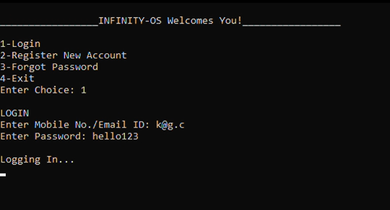
LOGIN PAGE

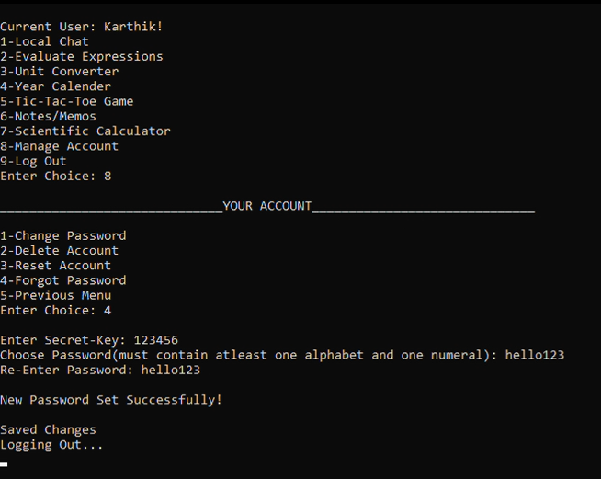
MANAGE ACCOUNT
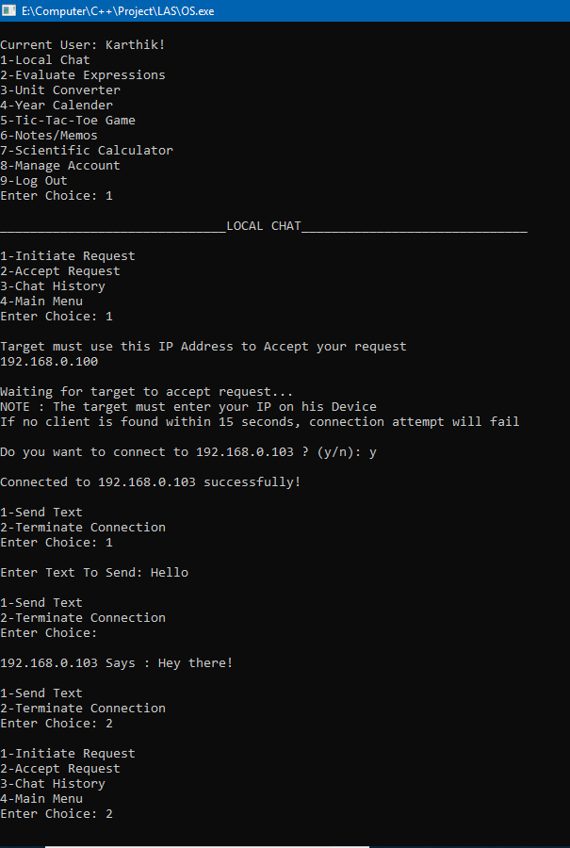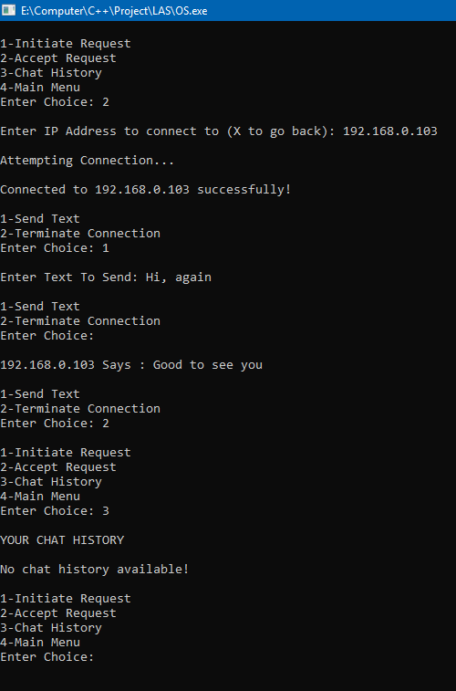
CHAT SERVER
CHAT CLIENT

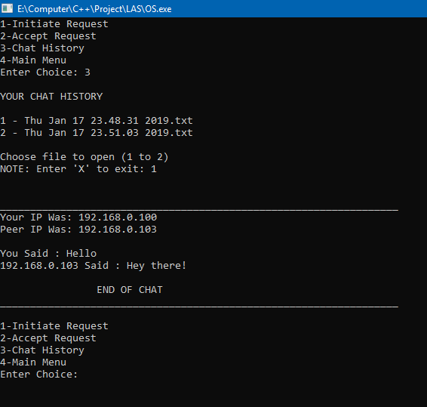
CHAT HISTORY

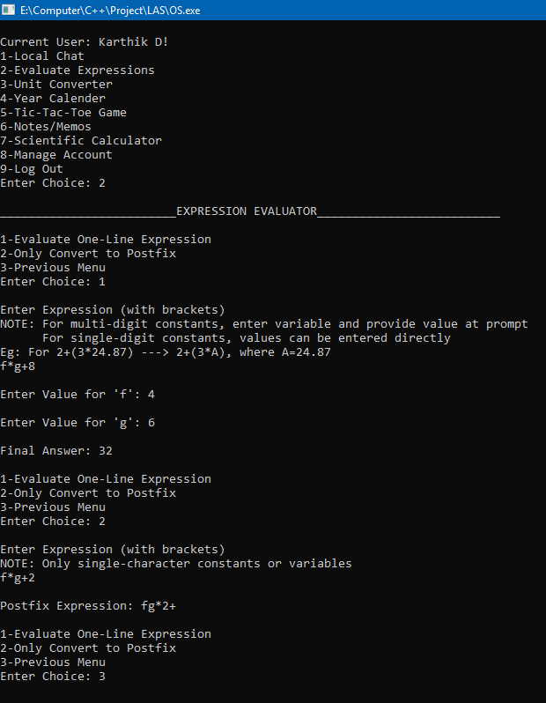
EXPRESSION
EVALUATOR

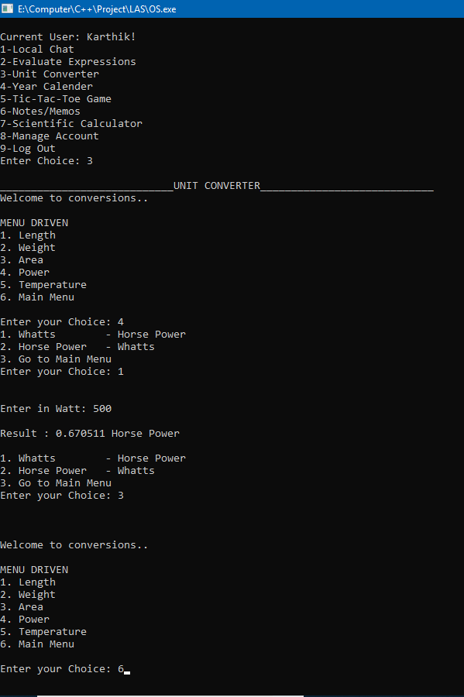
UNIT
CONVERTER

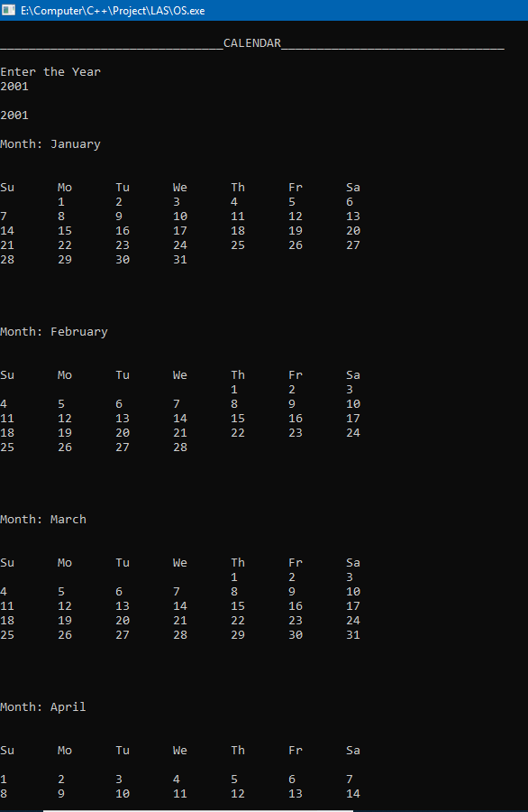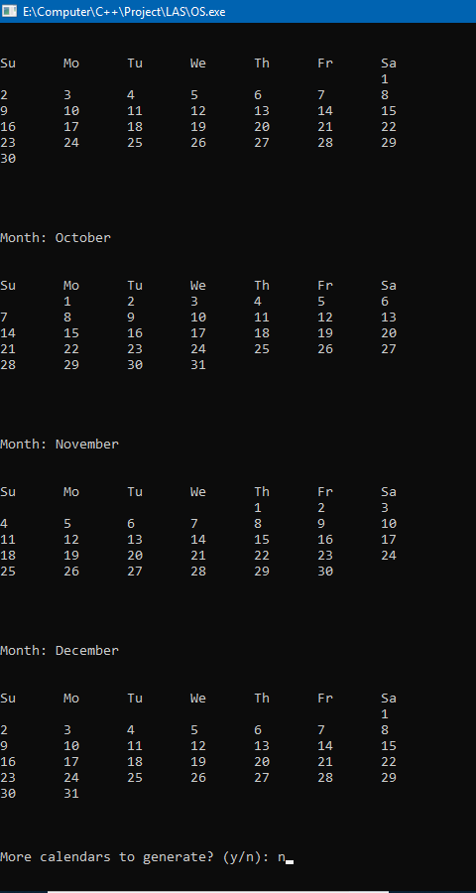
CALENDER
CALENDER

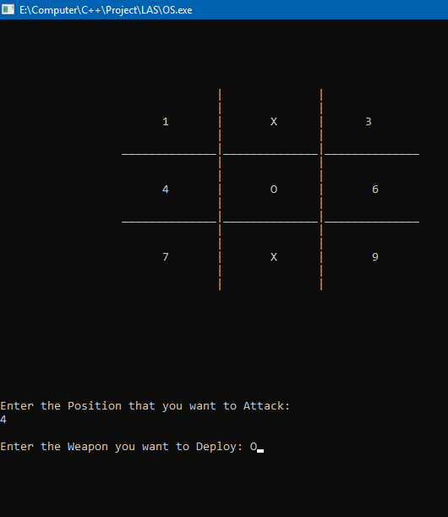
TIC-TAC-TOE

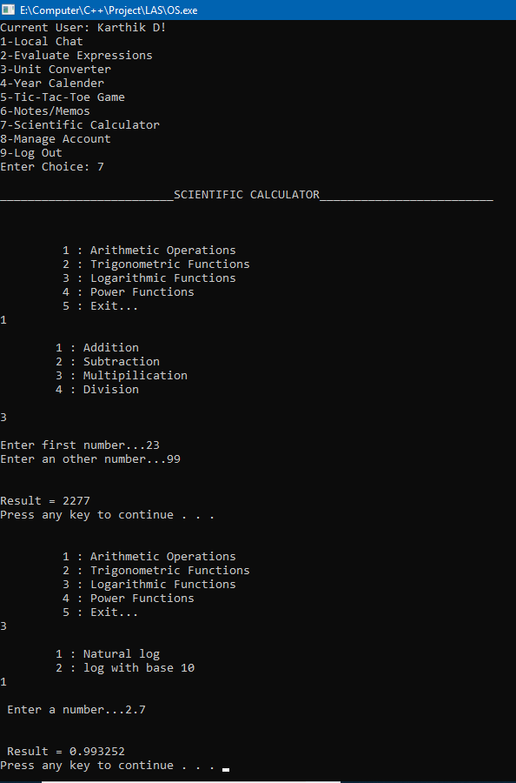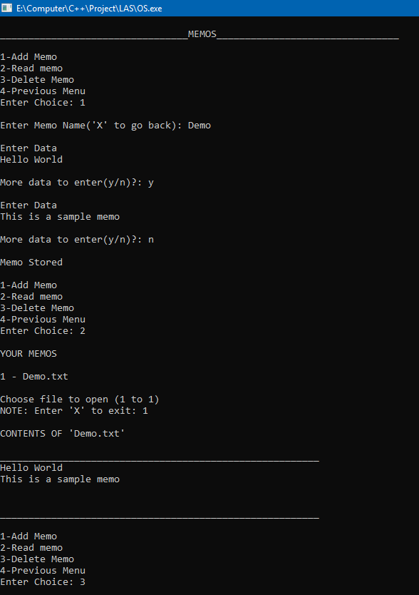
SCIENTIFIC
CALCULATOR
NOTES/MEMO

Constraints and Scope

We plan to work on these aspects and features of the software in future:
- The chat environment can be made more user-friendly with a GUI.

- The chat environment can be improved to handle group chats.

- The local area connection can also be extended for sending and receiving small sized files and handling a group of users instead of having one sender and one receiver.

- Developing a Centralized Database Server to avoid user redundancy across devices.

- Features to verify phone numbers and emails entered by users during registration apart from the existing theoretical algorithms to further avoid user redundancy.

- The entire Operating System Simulation can be made into a Graphical User Interface (GUI) to facilitate a user-friendly environment, make error handling efficient and easier and dynamic pages with real-time prompts and data entry which will enhance user experience and make it more appealing.

These shortcomings can be rectified over a stretch of time so as to be able to provide a real-time user-friendly interface of an Operating System

Bibliography

- https://docs.microsoft.com/en-us/windows/desktop/winsock
- https://digitalmars.com/rtl/direct.html
- http://www.cs.colostate.edu/~gersch/cs457/CS457_tutorial2.pdf
- https://www.geeksforgeeks.org/socket-programming-cc/
- https://www.tutorialspoint.com/unix_sockets/what_is_socket.htm
- https://www.programiz.com/cpp-programming/object-class
- https://dev.to/ichtrojan/understanding-basic-object-oriented
- https://stackoverflow.com/questions/10872168/math-oriented
- http://pubs.opengroup.org/onlinepubs/7908799/xsh/dirent.h.html
- http://www.cplusplus.com/reference/ctime/
- Grade XII Textbook in Computer Science – Sumita Arora
- C++ Class, Function and Method Documentation

